**Capstone project documentation**

[sharmi2504/capstone-project (github.com)](https://github.com/sharmi2504/capstone-project/tree/dev) [ my github URL]

13.126.61.124:80 [ deploy site URL]

**Installing the necessary software’s & services for this task:**

1. **Git**
2. **Docker**
3. **Docker compose**
4. **Java**
5. **Jenkins**

Before install git. we have to launch an instance. select ubuntu

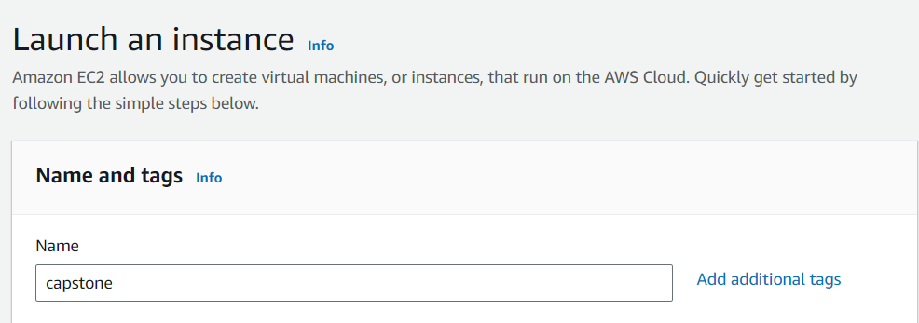

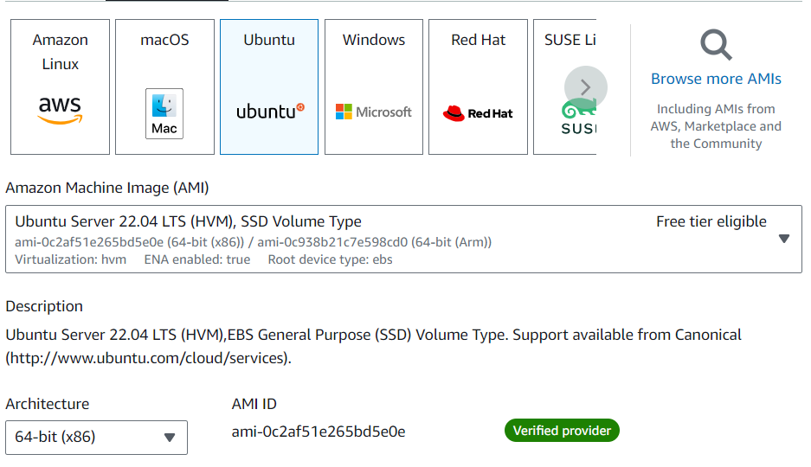





Connect that instance

1. **Git installation:**

sudo apt update

sudo apt install git -y

git --version

sudo apt update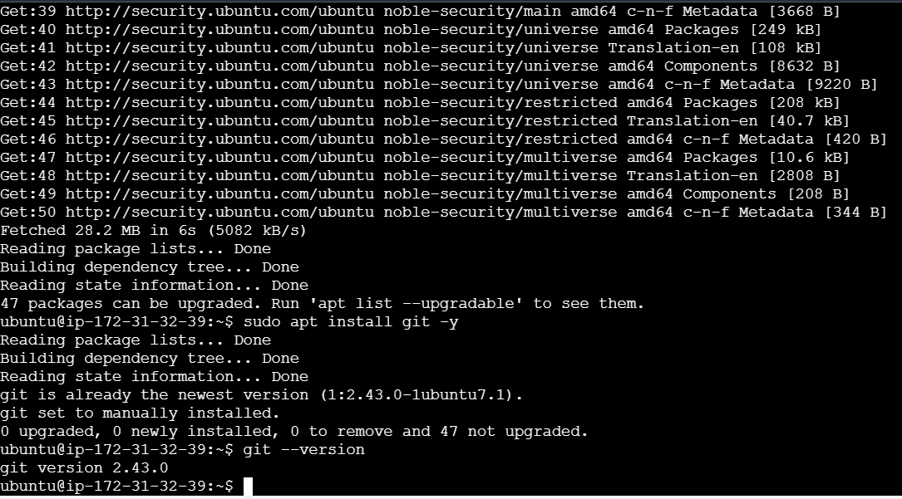



Clone the given repo

git clone <https://github.com/sriram-R-krishnan/devops-build>

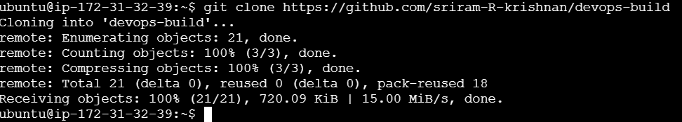

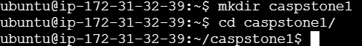

1. **Docker installation:**

sudo apt update

sudo apt install docker.io

sudo docker version

sudo usermod -aG docker ubuntu

sudo systemctl status docker

sudo apt update

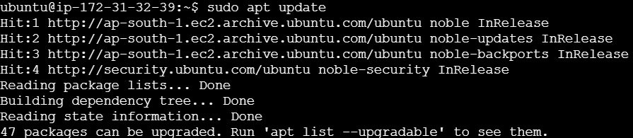

sudo apt install docker.io

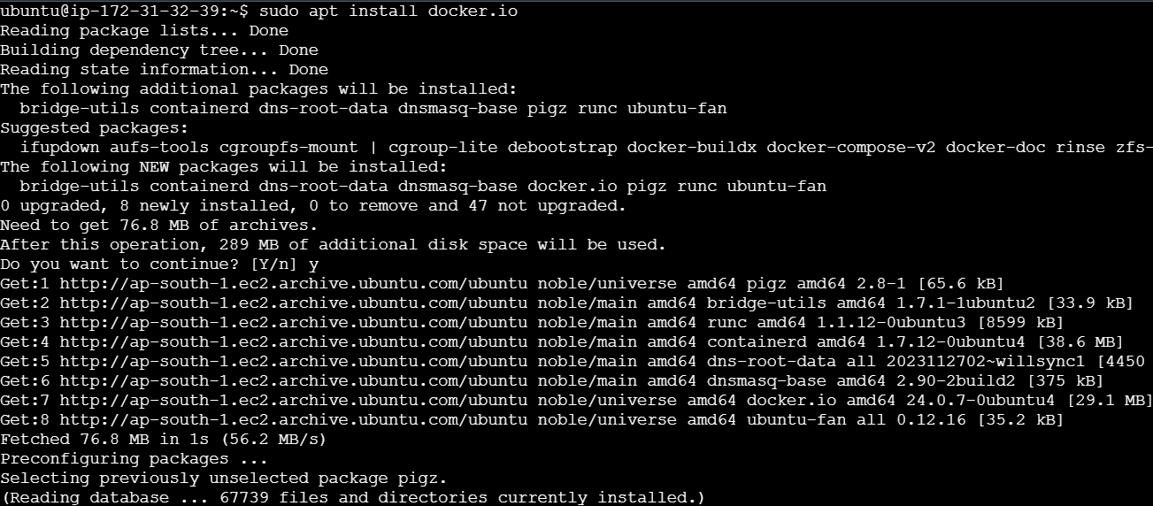

sudo docker version

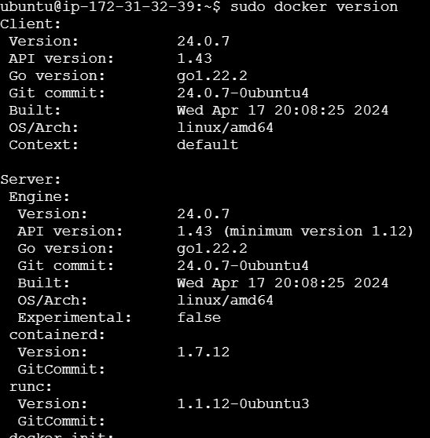

sudo usermod -aG docker ubuntu



sudo systemctl status docker

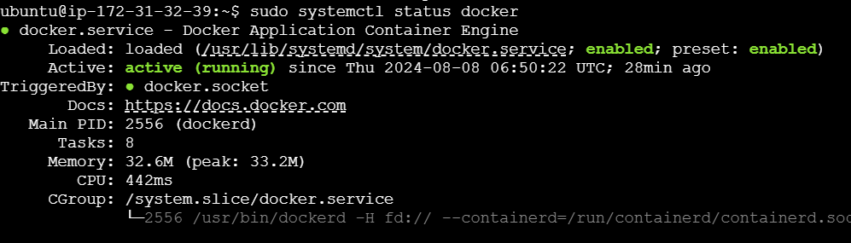

sudo systemctl start docker

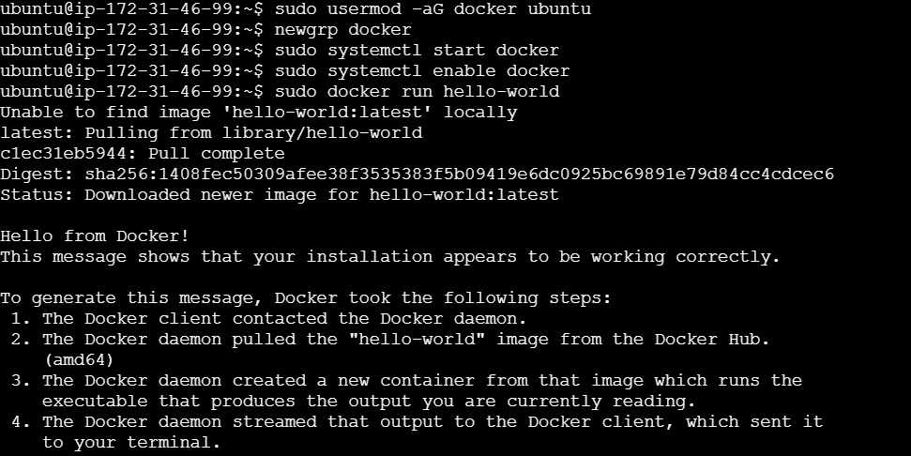

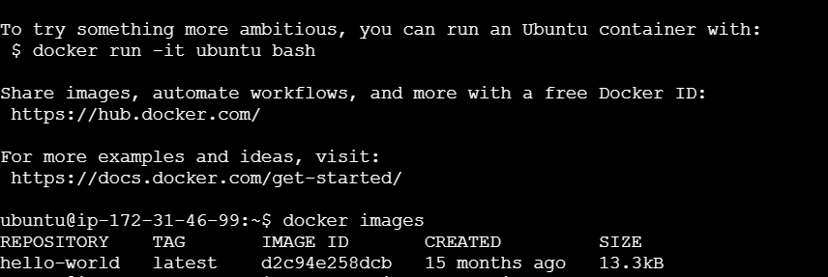

**docker file:**

**vi dockerfile**

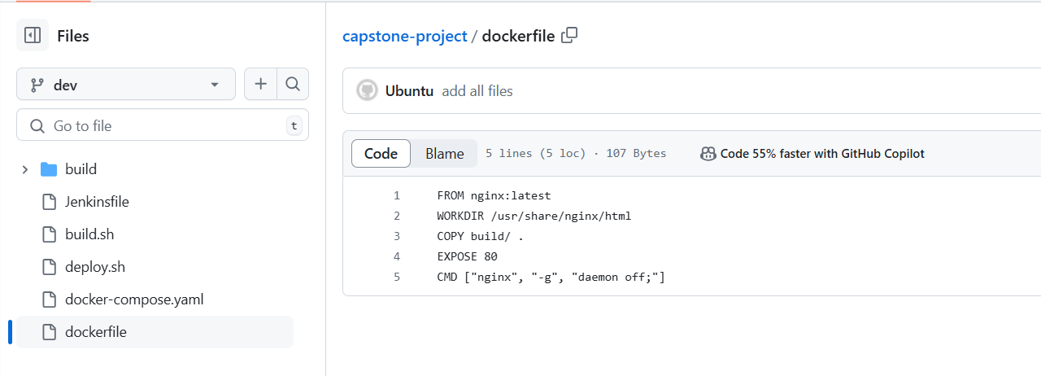

**Convert docker file into docker image:**

**docker build -t nginximage .** 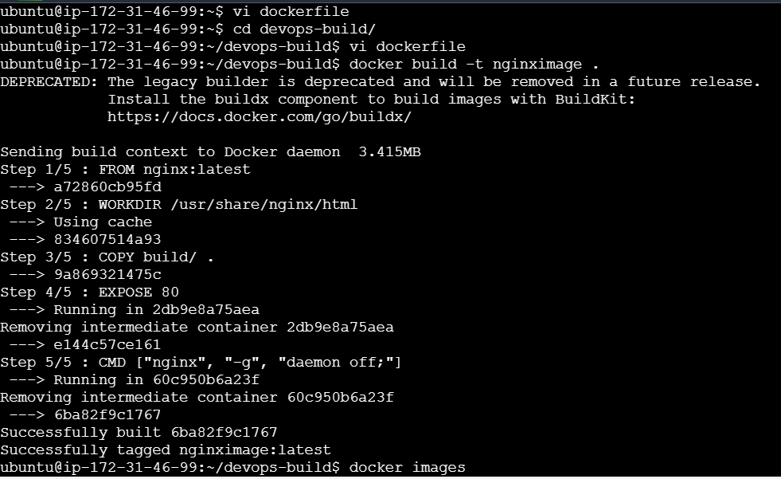



**docker images**

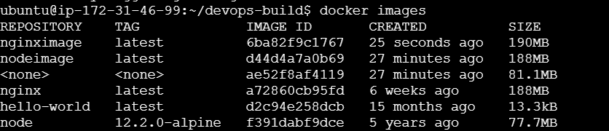

**docker run -d --name mynignxcontainer -p 80:80 nginximage**



**docker ps**



**Open the port no :80 in ec2. Copy and paste the ip address**

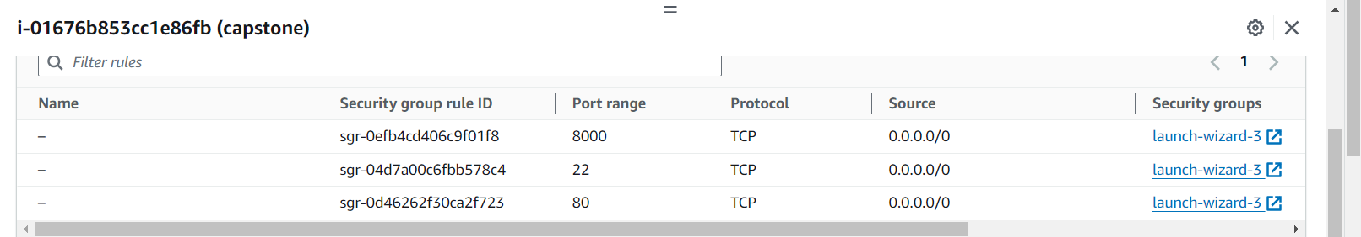

**Output page of given application:**

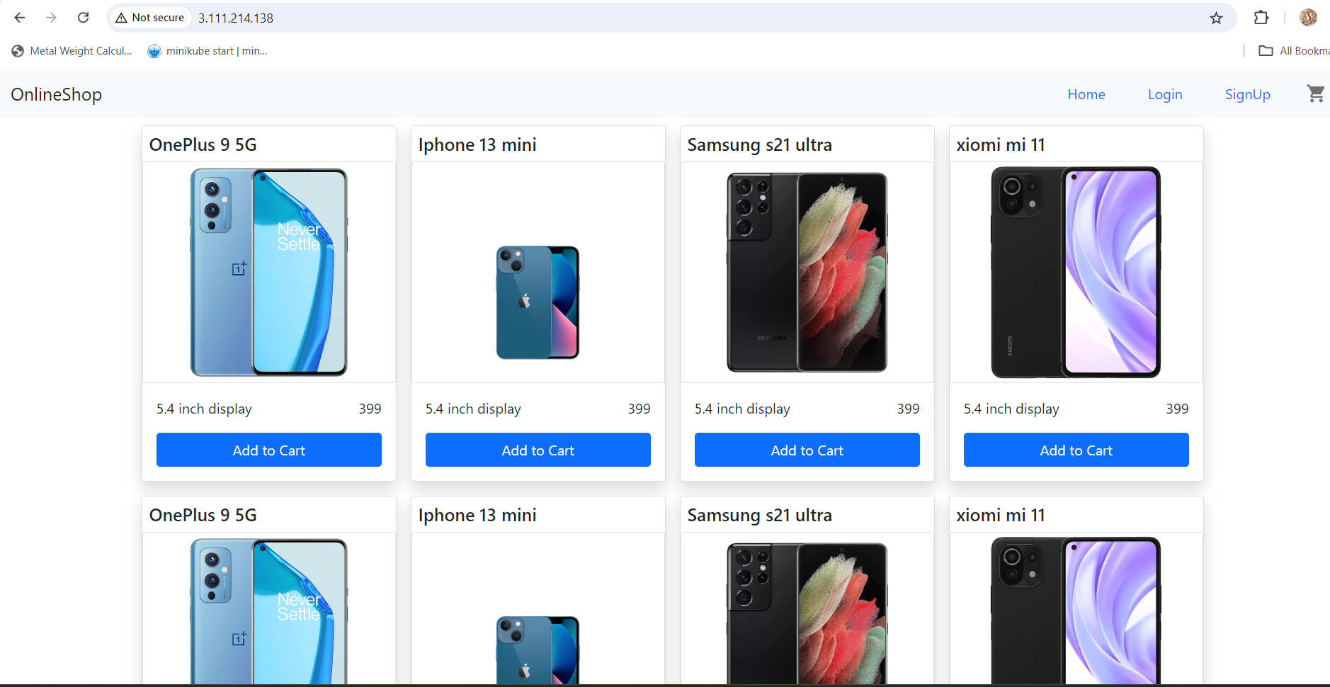

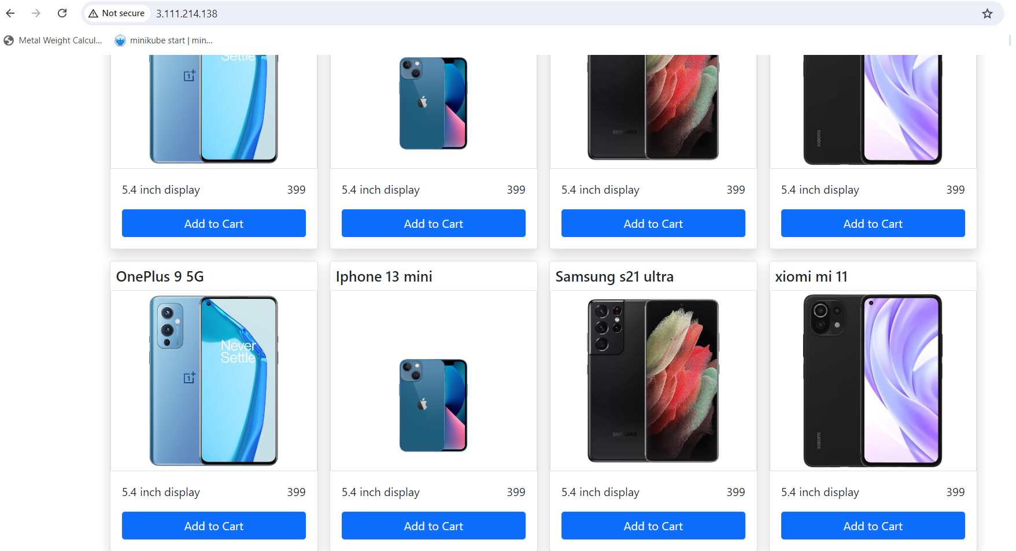

1. **Docker compose installation:**

sudo apt update

sudo curl -L "https://github.com/docker/compose/releases/download/1.29.2/docker-compose-$(uname -s)-$(uname -m)" -o /usr/local/bin/docker-compose

sudo chmod +x /usr/local/bin/docker-compose

docker-compose --version

sudo apt update [ update ubuntu machine]

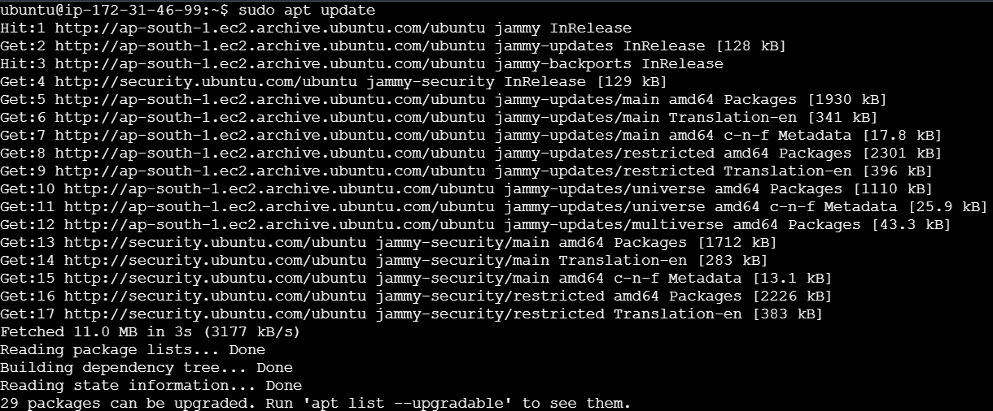

sudo curl -L "https://github.com/docker/compose/releases/download/1.29.2/docker-compose-$(uname -s)-$(uname -m)" -o /usr/local/bin/docker-compose



sudo chmod +x /usr/local/bin/docker-compose



docker-compose --version

**Docker compose file for node js:**

**get into folder devops-build. Then write this**



**vi docker-compose.yaml**

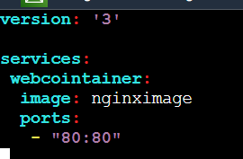

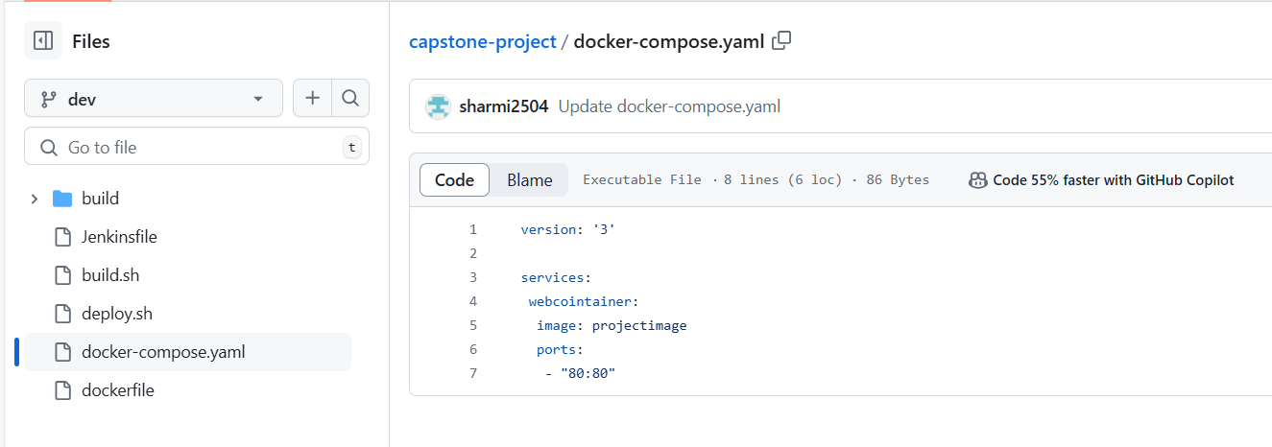

**Give permission for this file:**

**Chmod 777 docker-compose.yaml [ give permission for the docker-compose.yaml file]**



**Execute the docker-compose.yaml :**

**docker-compose up -d**



**docker ps**



**Bash scripting:**

* **build.sh**
* **deploy.sh**

**Build.sh file:**



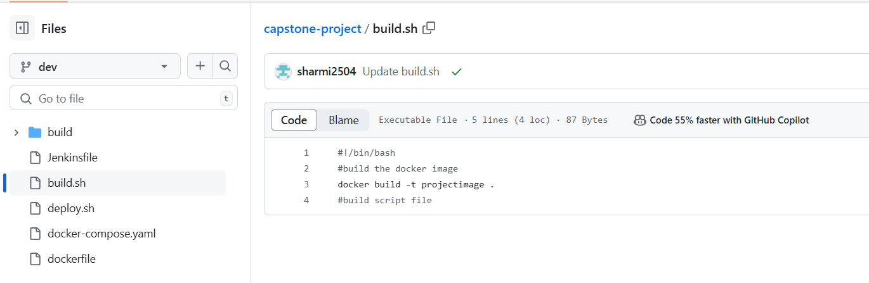

Your docker login details [ create the new docker hub account]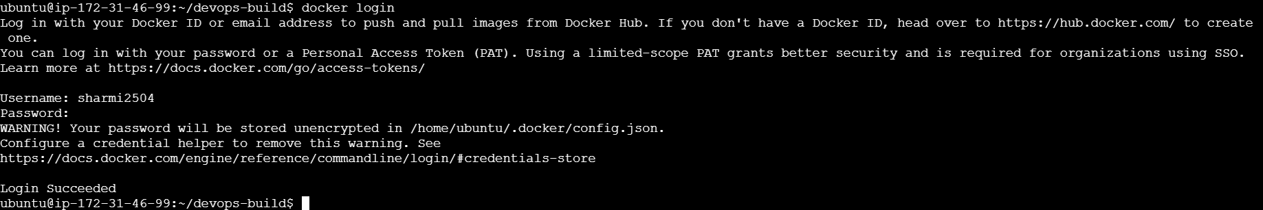

**deploy.sh:**

**deploy.sh file:**



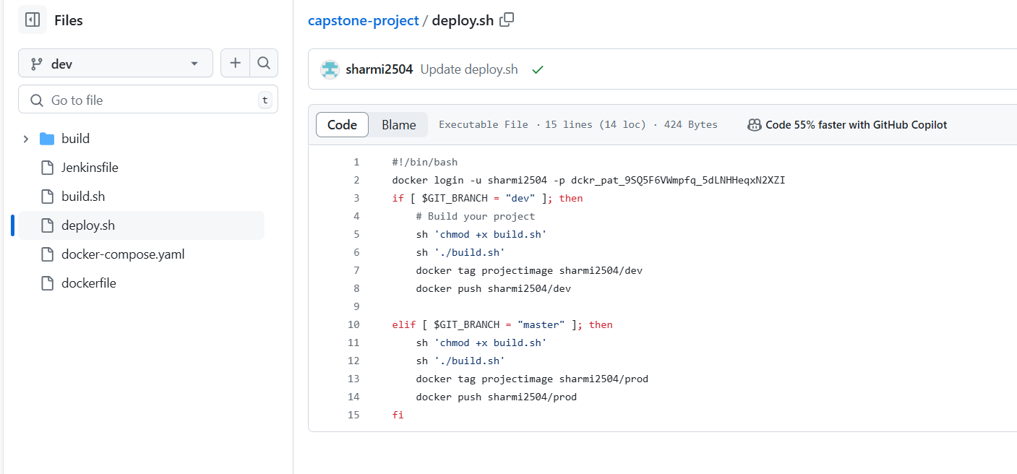

**Create new repo in git:**

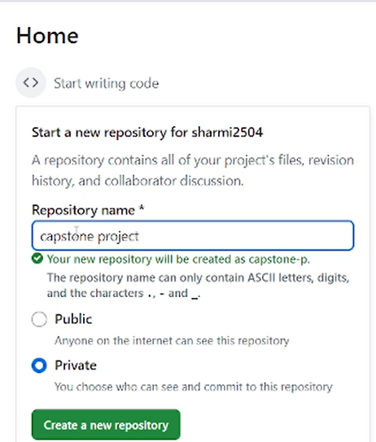



**Give public repo**



After create repo. you get this https link. copy and paste it in clone command



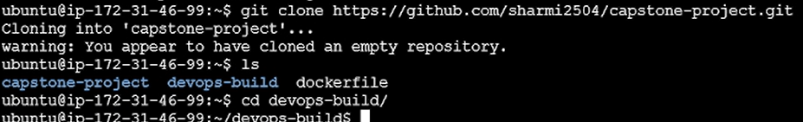

Here capstone-project directory created repo in GitHub. get into that dir . them move that all files from devops-build to capstone-project dir . in our own repo we push all our files.

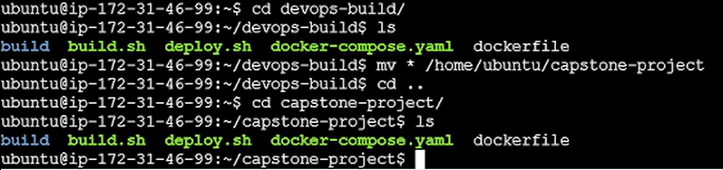

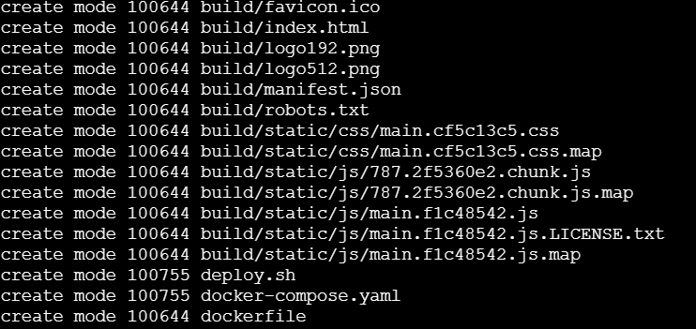

**git add .** [ add all files in our repo]

**git commit -m “add all files”**

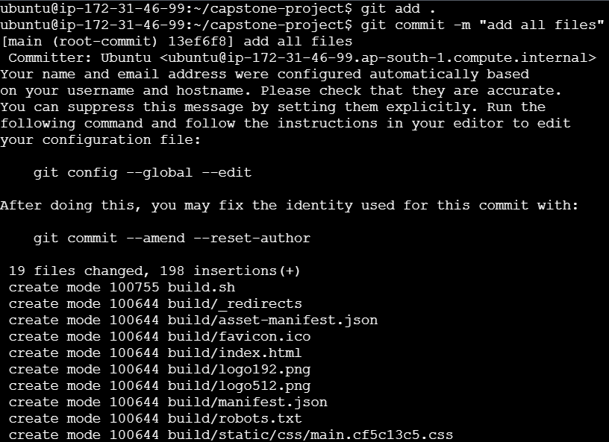

All files move in that repo [ capstone-project]. then created dev branch. Inside dev branch we add all files.

**Create dev branch in git:**

**git checkout -b dev [** Create dev branch**]**





**git add .** [ add all files in our repo]

**git commit -m “add all files”**

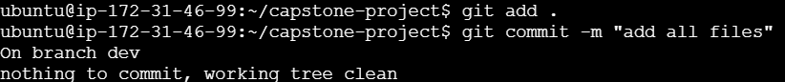

**git push -u origin dev [ push all files in our repo]**

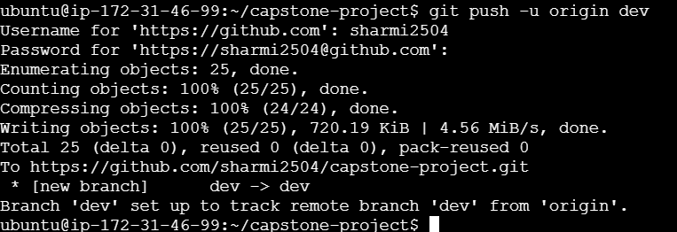

Copy and paste the token in password

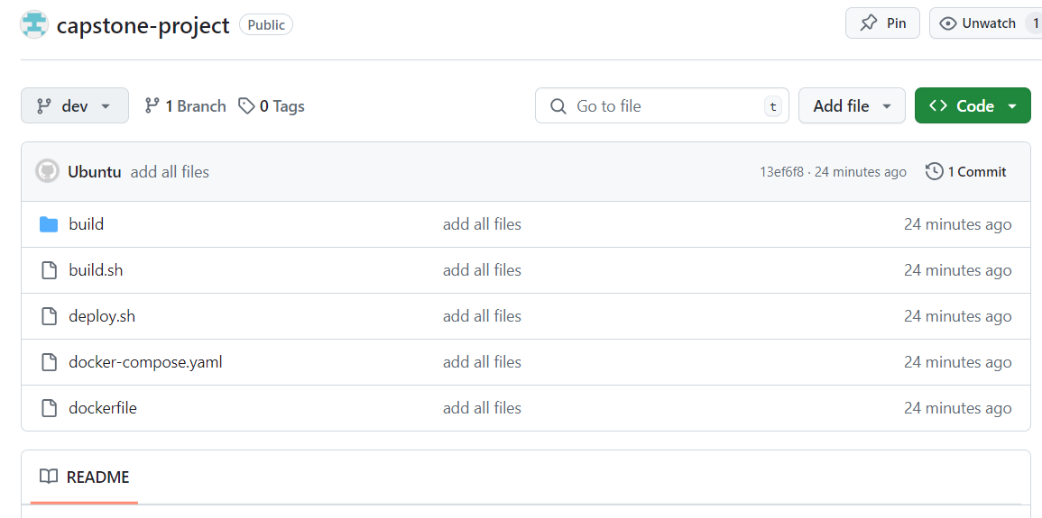

All files pushed to our repo.

1. **Jenkins installation:**

sudo apt-get update

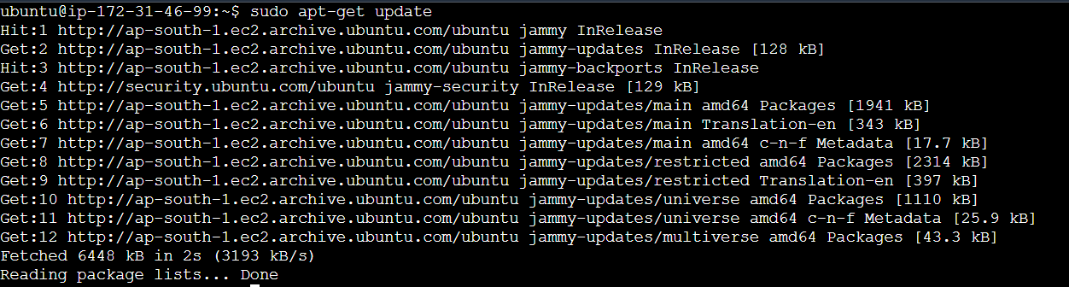

sudo apt-get install -y openjdk-11-jdk

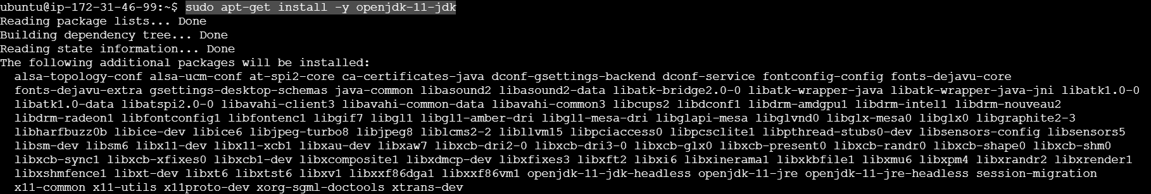

sudo wget -O /usr/share/keyrings/jenkins-keyring.asc \

https://pkg.jenkins.io/debian-stable/jenkins.io-2023.key

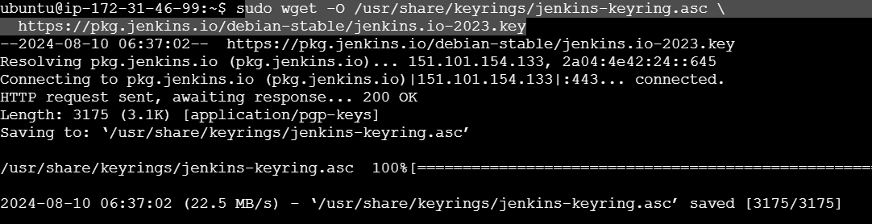

echo "deb [signed-by=/usr/share/keyrings/jenkins-keyring.asc]" \

https://pkg.jenkins.io/debian-stable binary/ | sudo tee \

/etc/apt/sources.list.d/jenkins.list > /dev/null



sudo apt-get update

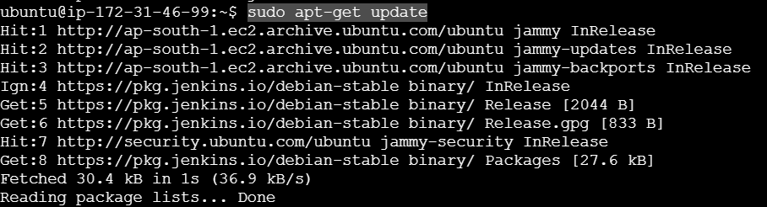

sudo apt-get install Jenkins

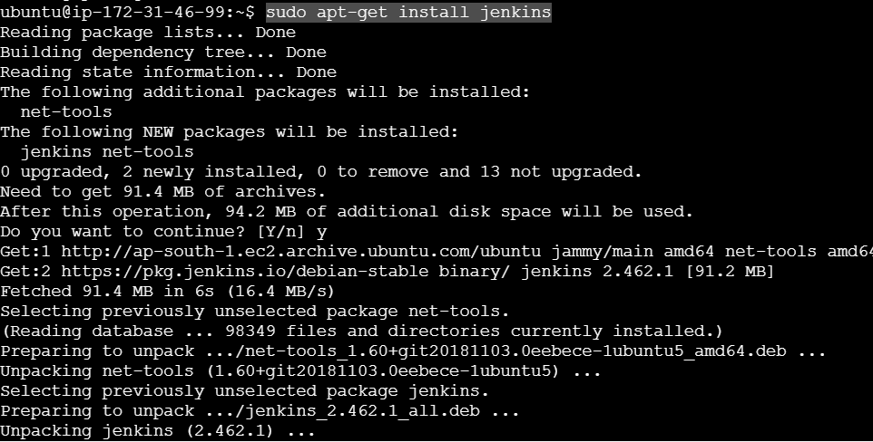

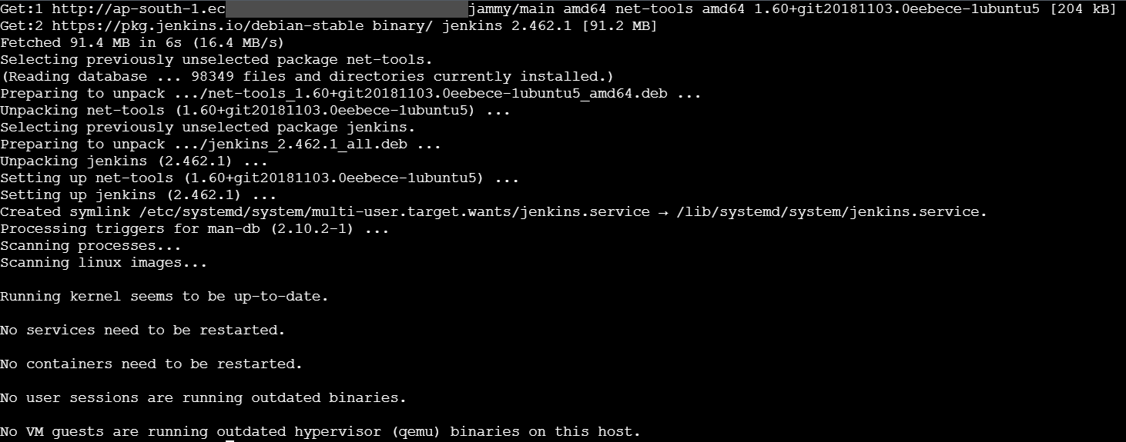

sudo systemctl start Jenkins



sudo systemctl status Jenkins

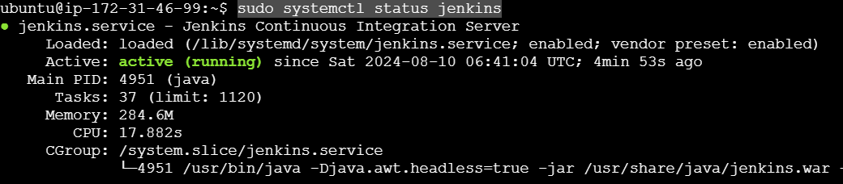



**Jenkins file:**

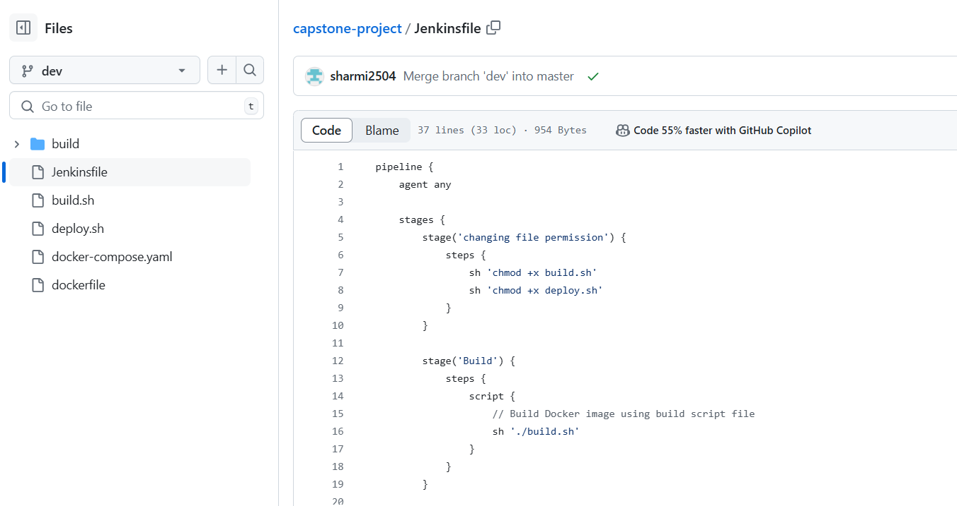

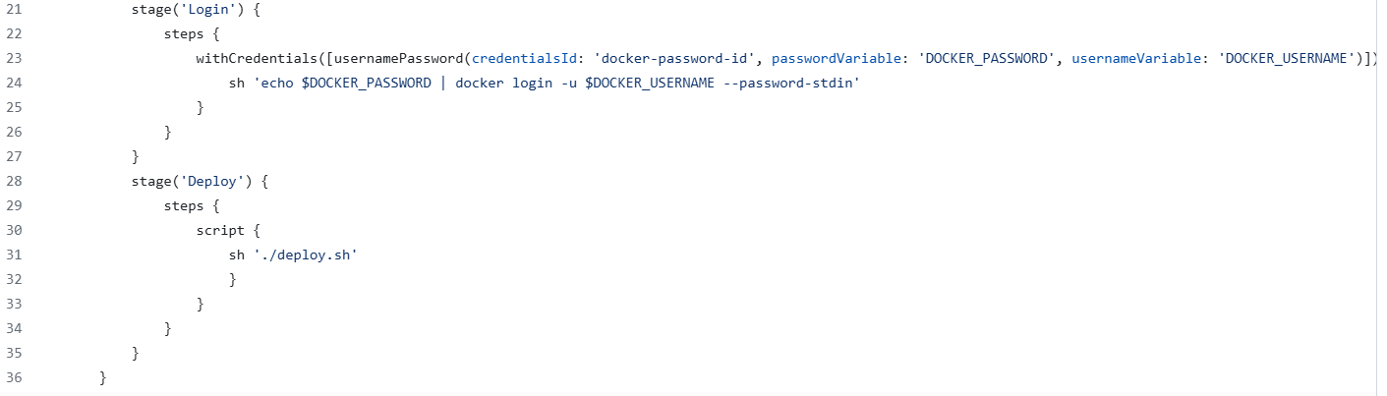

**Setup Jenkins dashboard:**

Add port no:8080 for access the Jenkins browser. Because it is a GUI tool

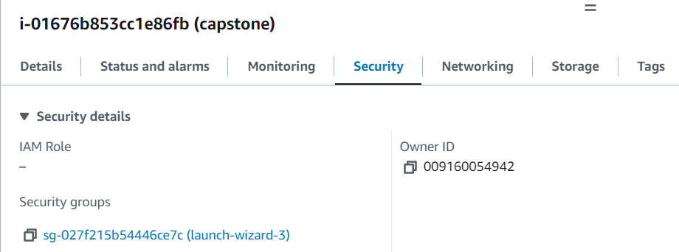

Click edit inbound rule

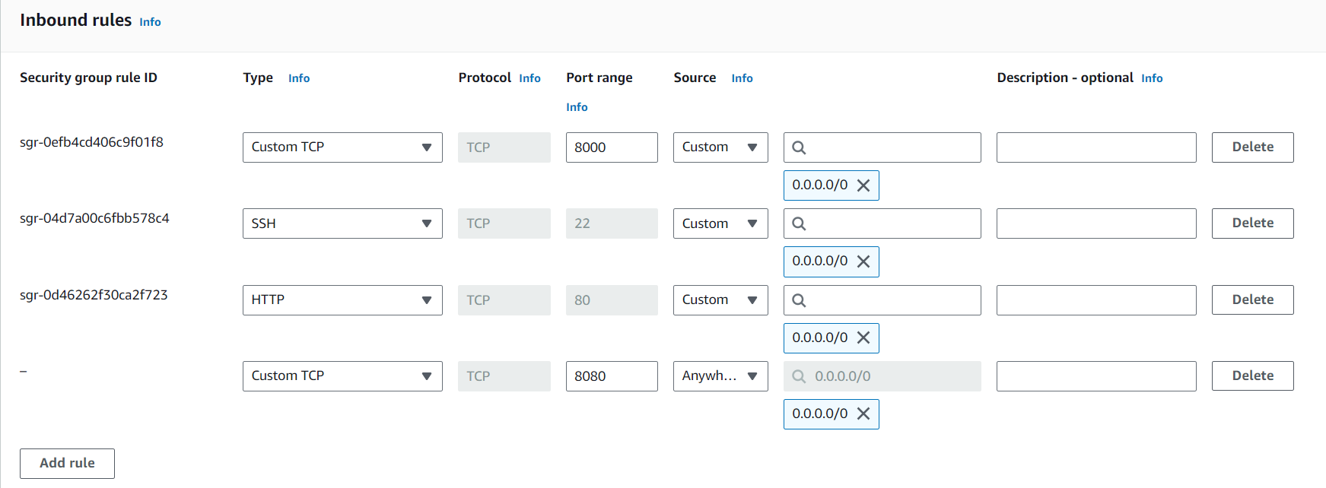

Click add rule 🡪 save rules. Copy ip address. Paste the address [65.2.31.200:8080]. give the Jenkins port number.

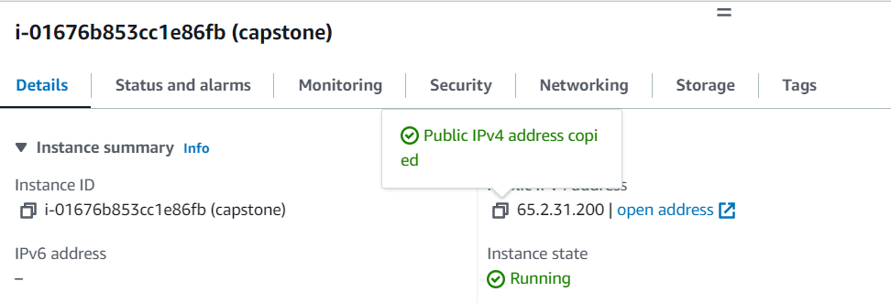

Copy ip address. Paste the address [65.2.31.200:8080]. give the Jenkins port number. Jenkins page opened.

Open Jenkins in browser:

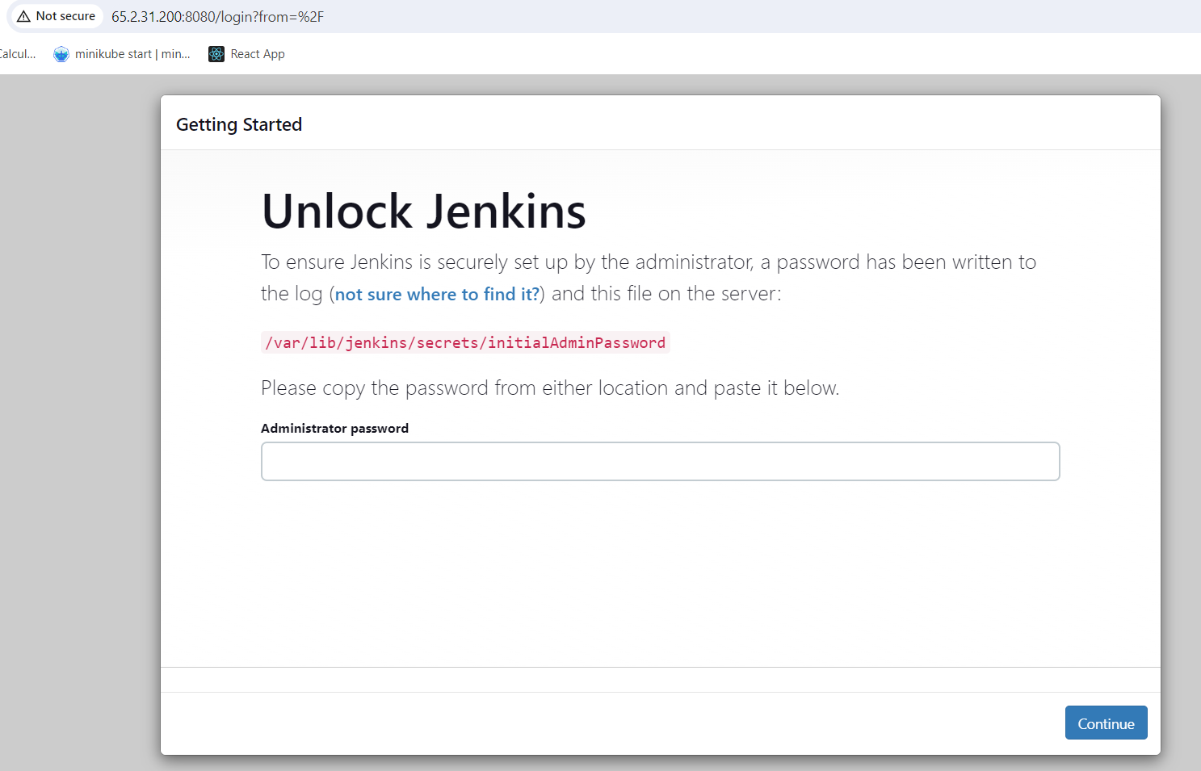

Get above password

sudo cat /var/lib/jenkins/secrets/initialAdminPassword [ get password for Jenkins ]



ef6201f275444ca8a144737522e1fa6d [ copy the password in above]

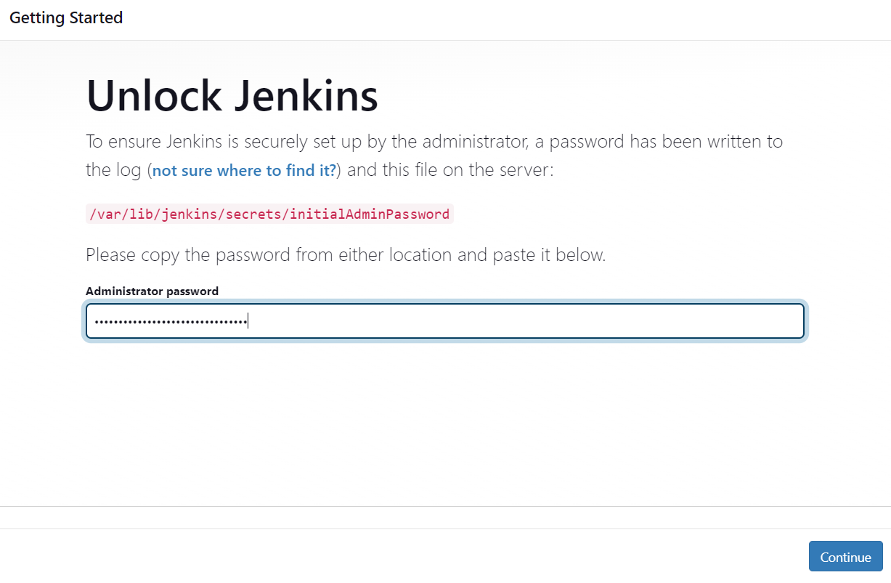

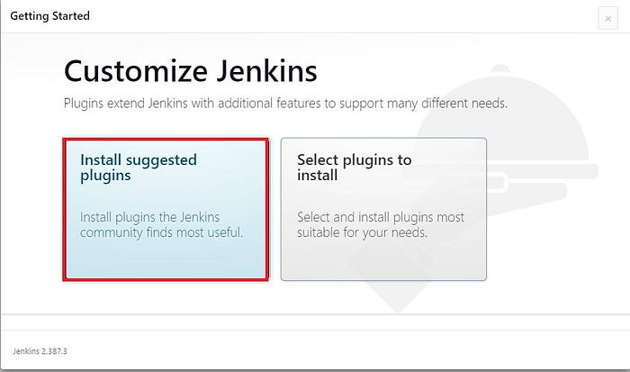

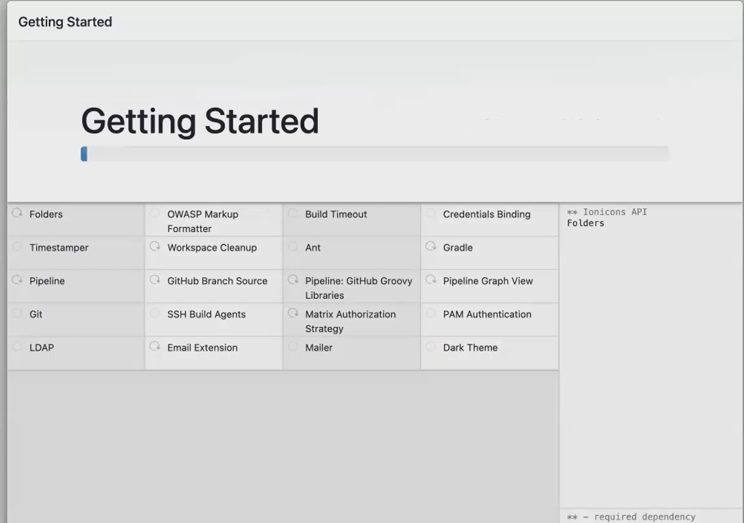

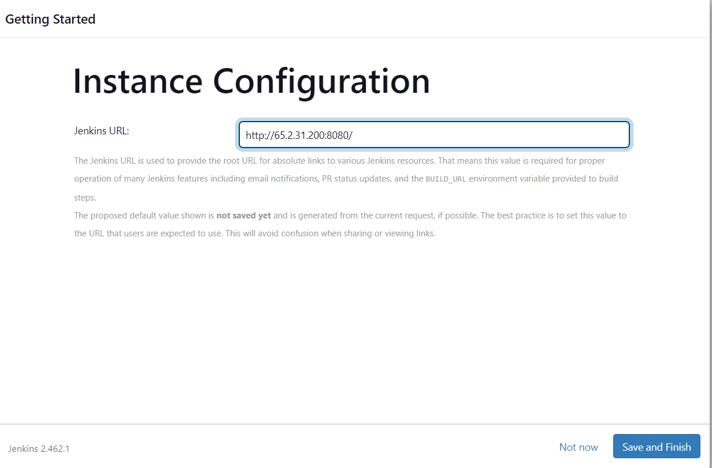

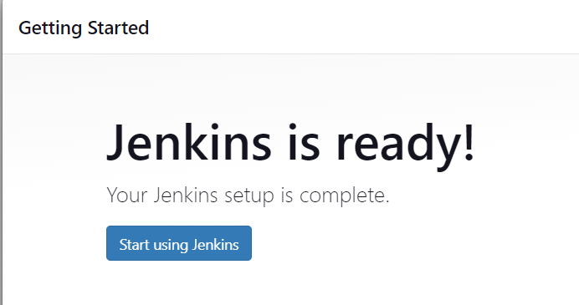

Before creating the job installed docker plugin in Jenkins and install docker in ec2 also.

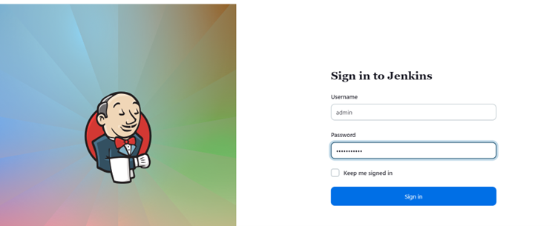

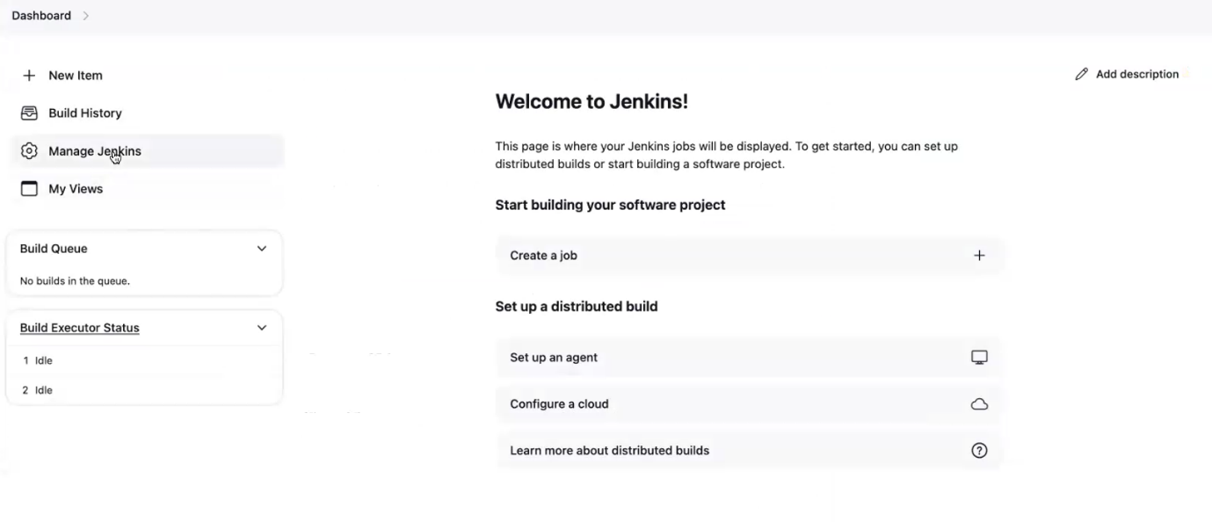

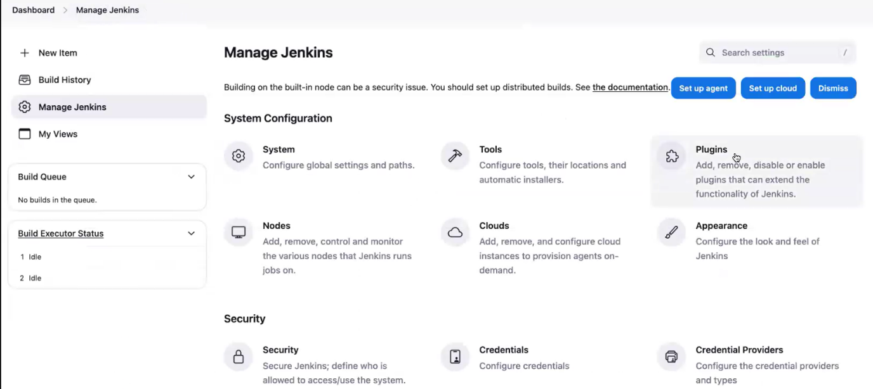

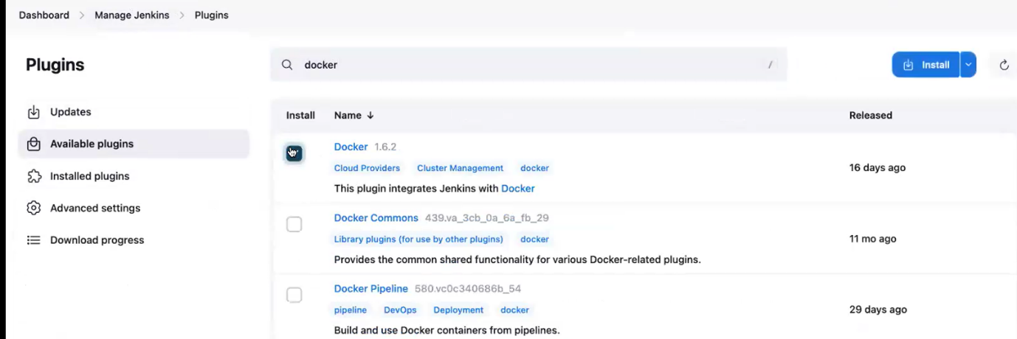

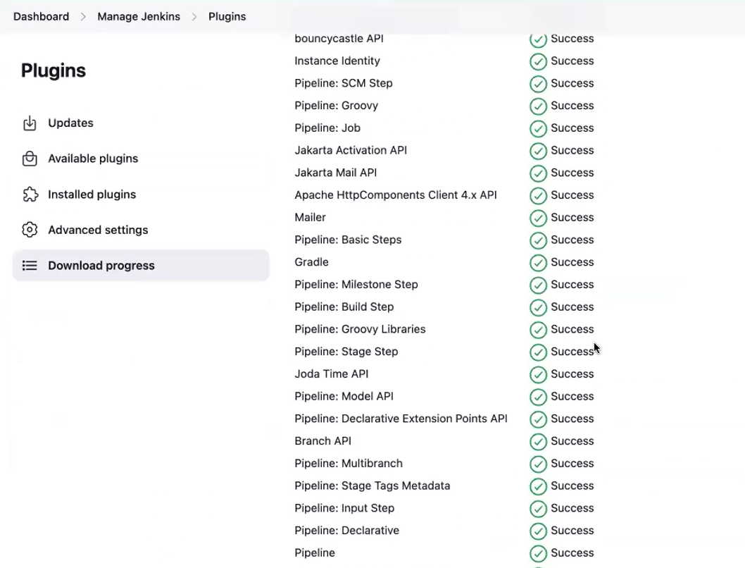

**Give docker permission for Jenkins. then only we have to build the docker image.**

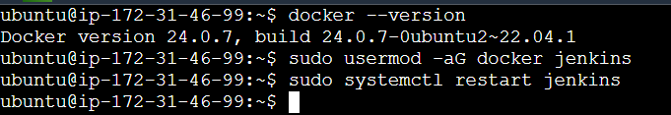

After give restart Jenkins, refresh the Jenkins page. again, ask Jenkins login and password.

**Add credentials:**

we have to pass the credentials for the Doctor Hub. **to push your image to the docker hub registry. You need to do a docker login. So, for docker login. You have to give the username and password. So, your Jenkins have to do the docker login.**

Add credentials

Click dashboard 🡪 manage Jenkins🡪 credentials

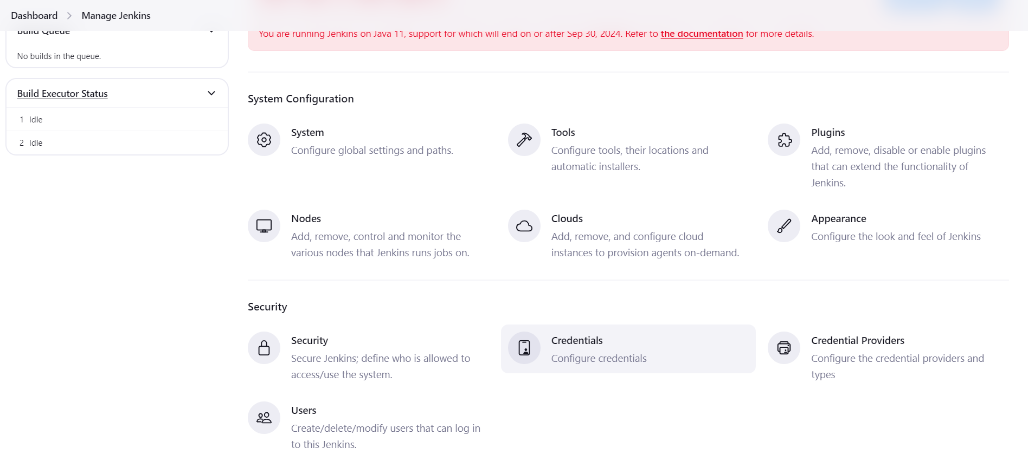

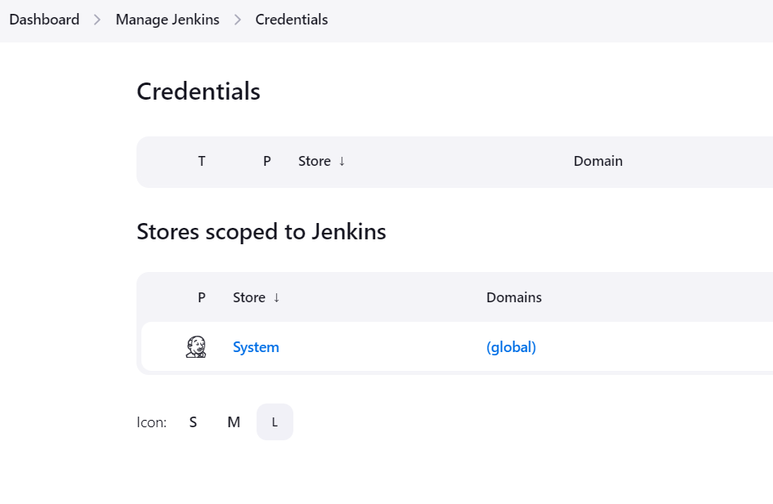

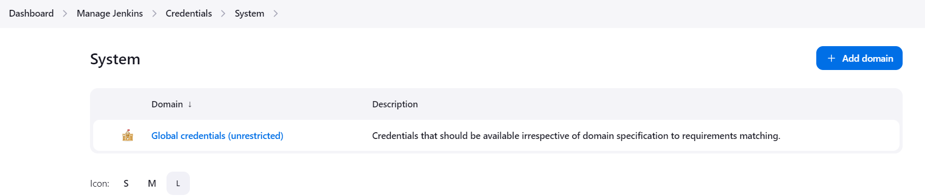

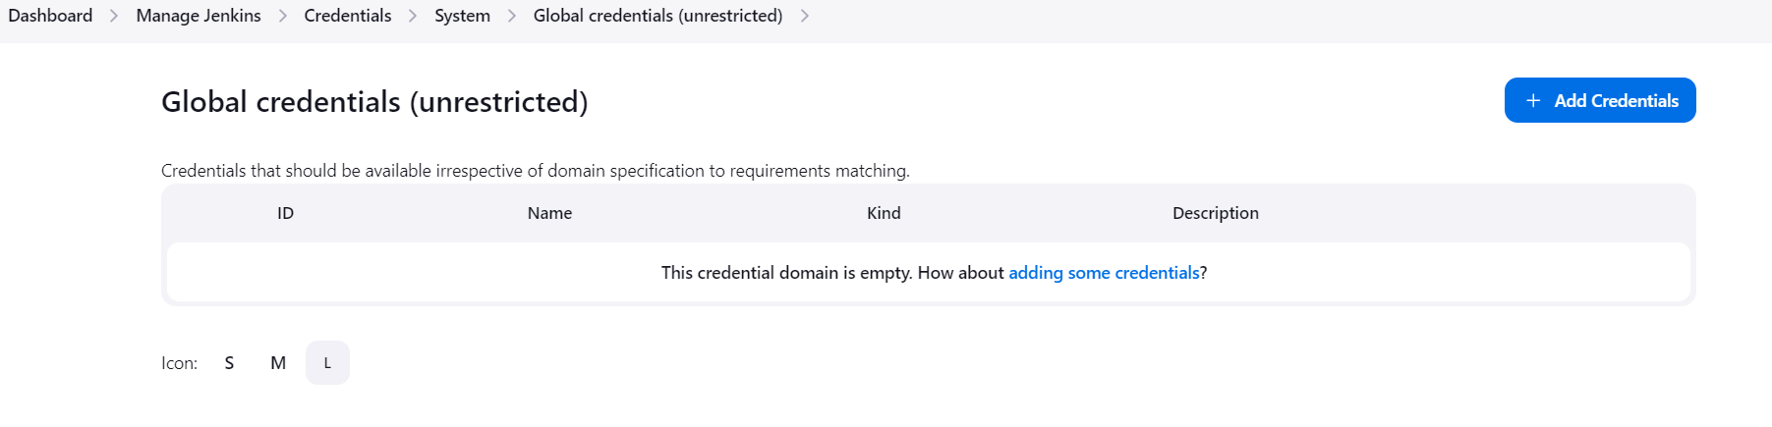

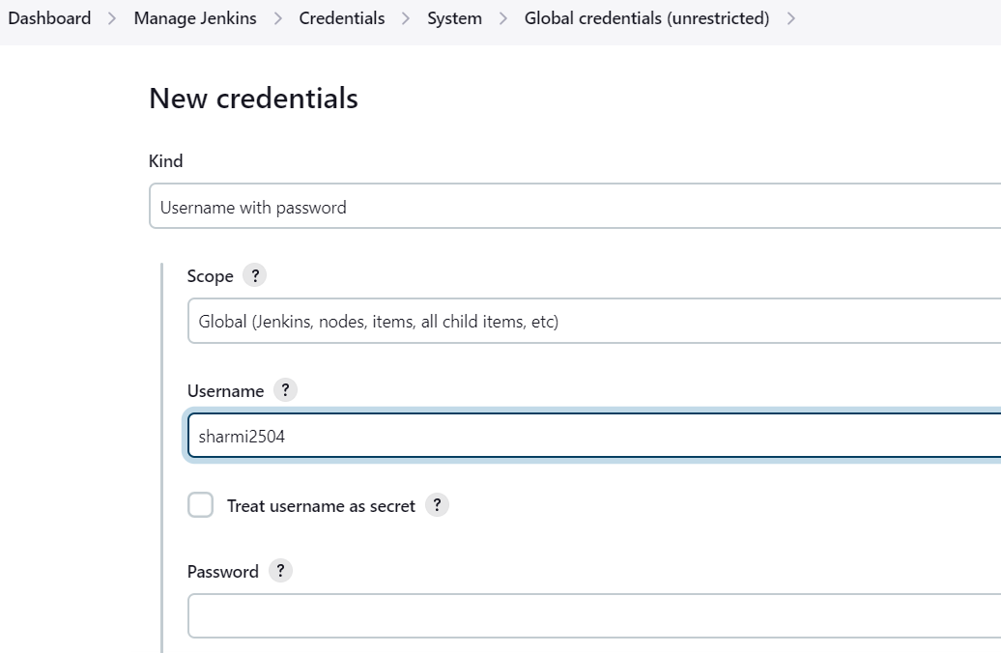

Above username is dockerhub user name.For password we generate tokens like github.

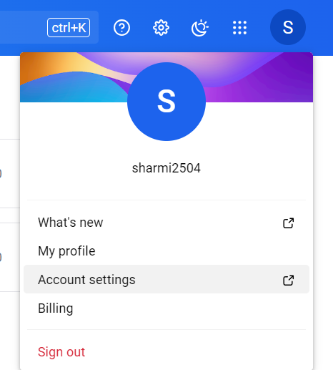

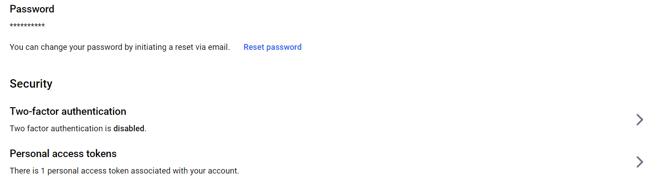

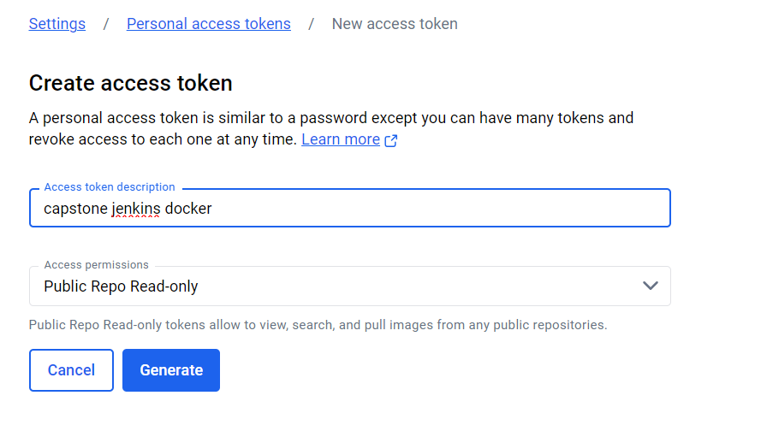

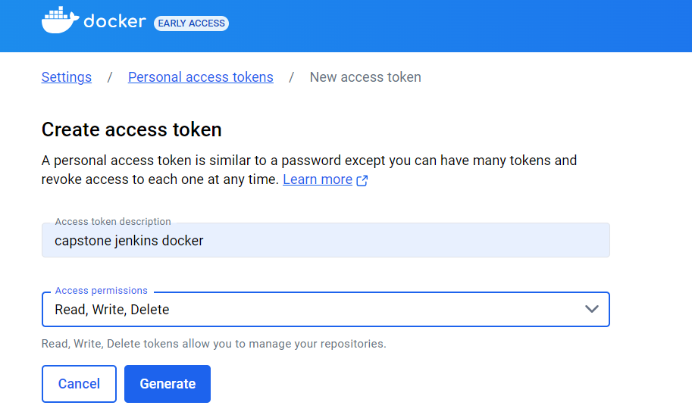

Copy the token, paste it in Jenkins

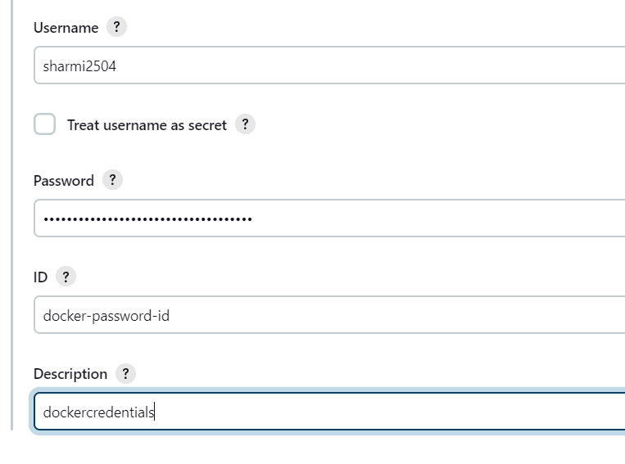

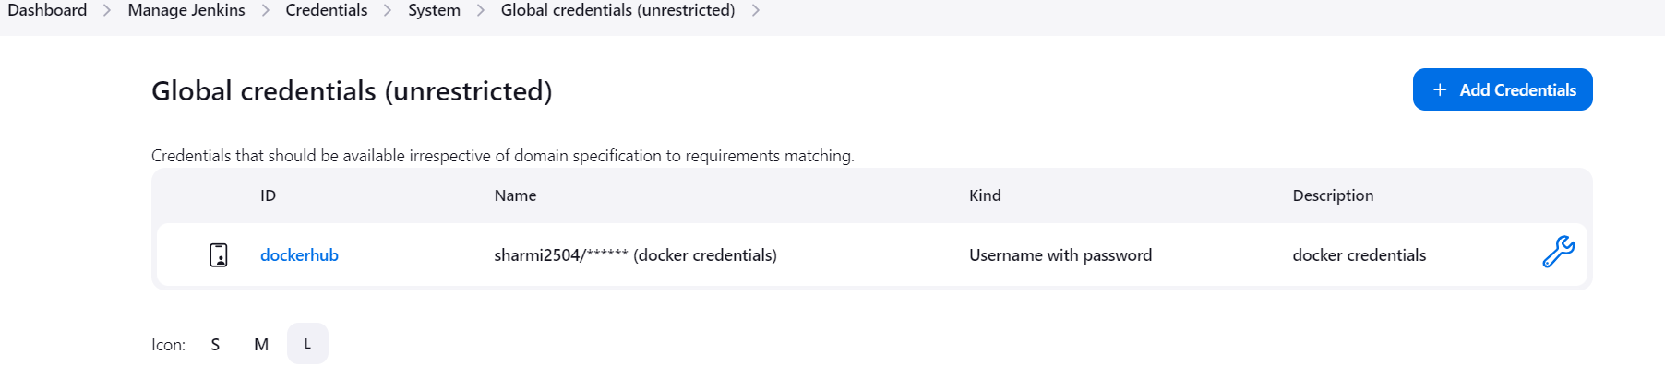**Now create the job in Jenkins:**

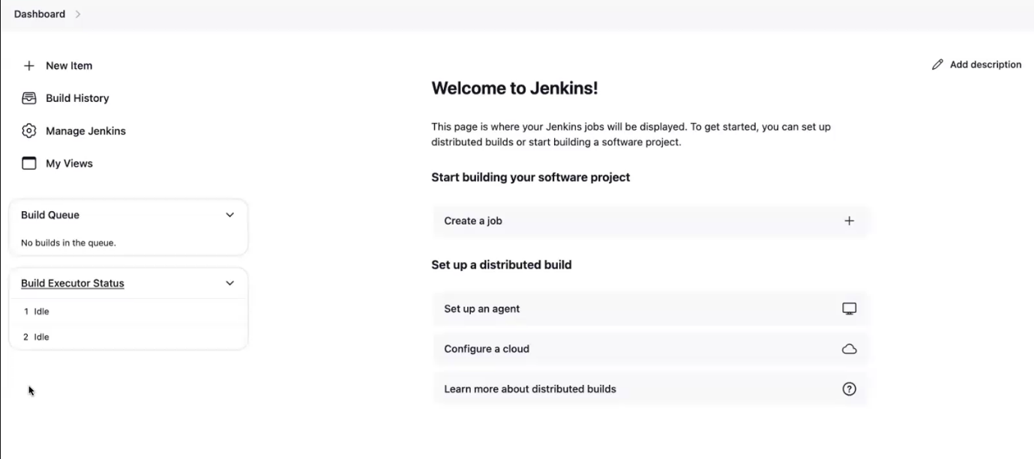

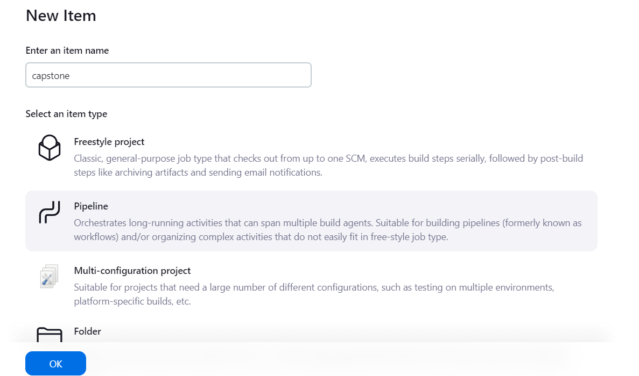

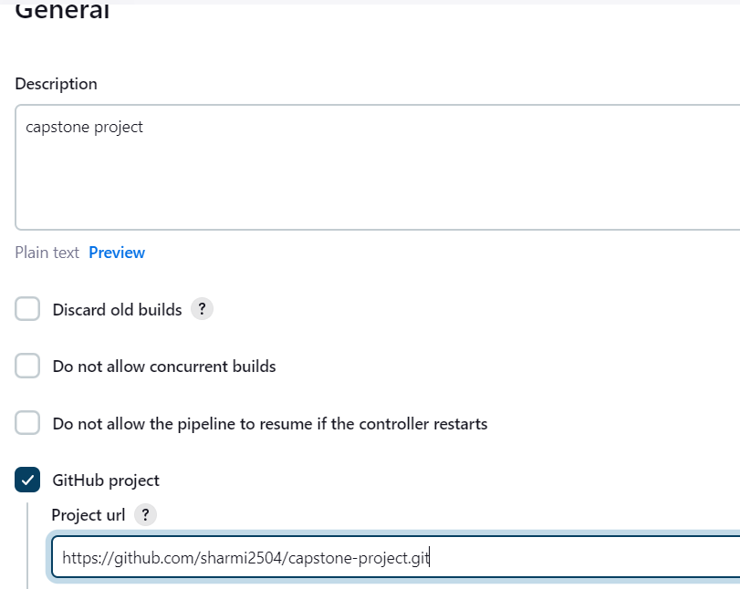

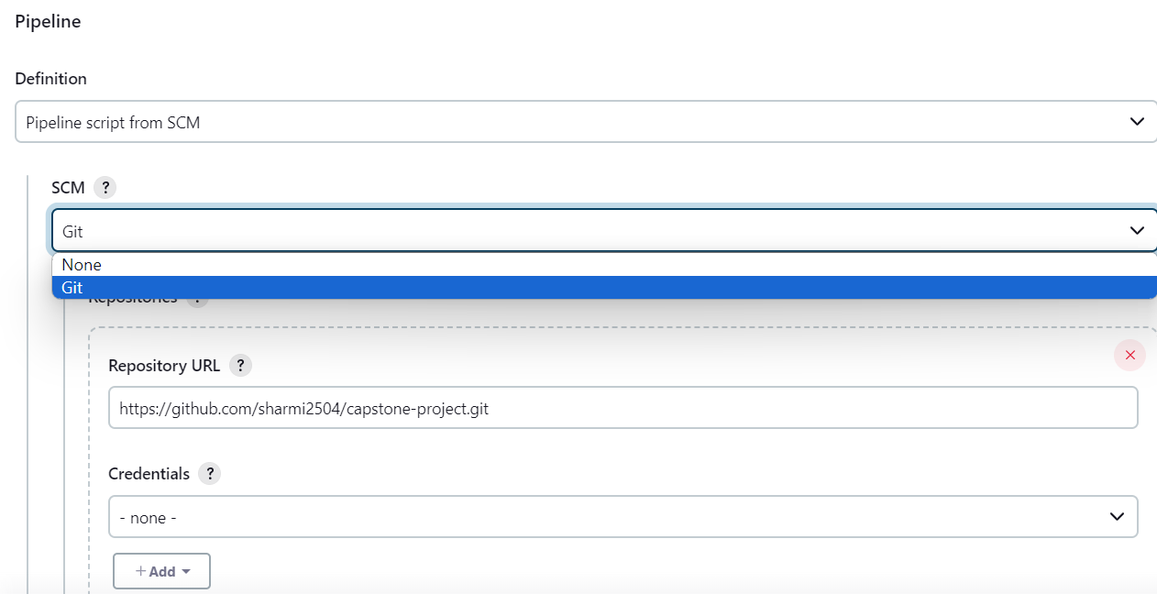

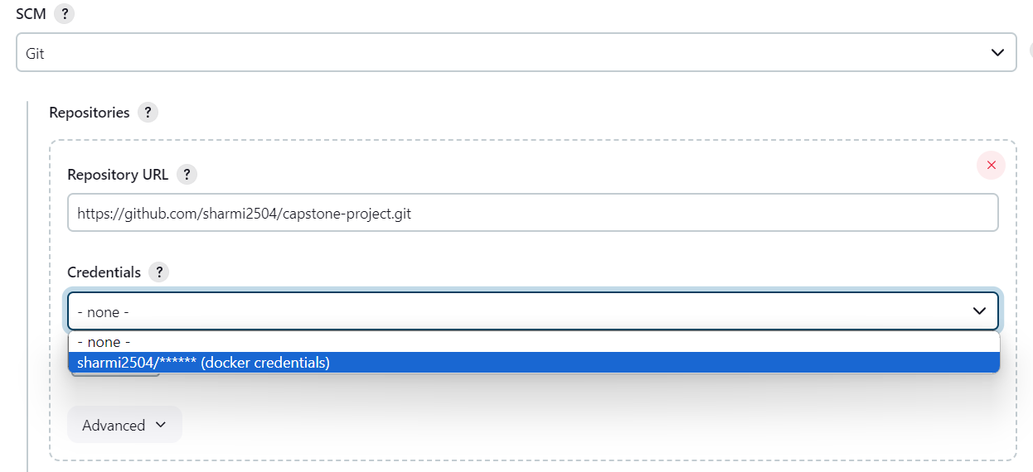

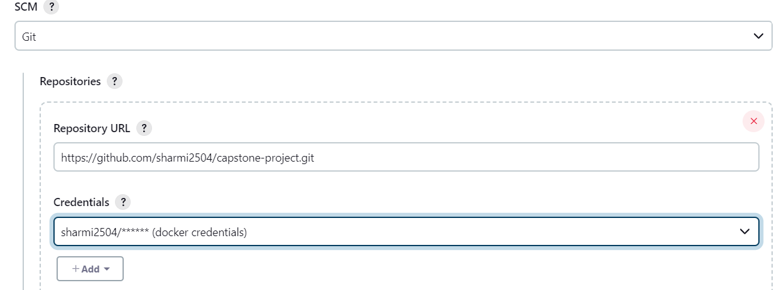

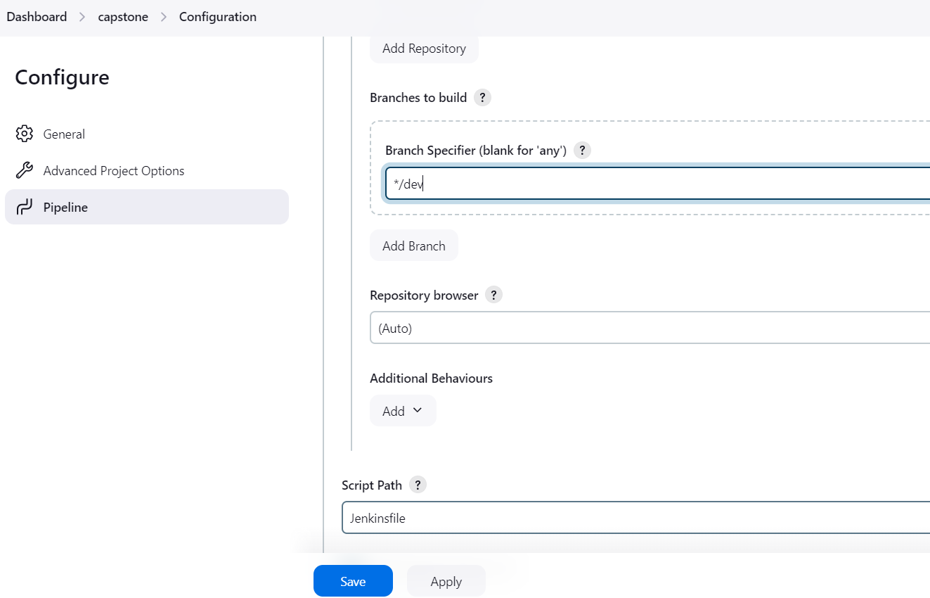

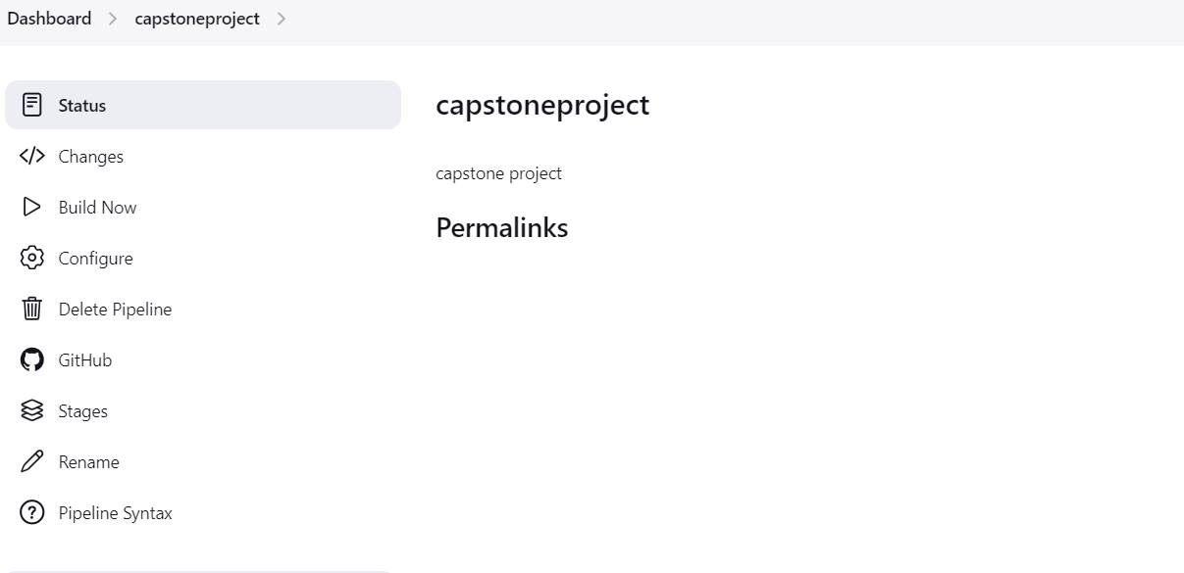

**Webhook in git:**

**Connect Jenkins to GitHub:**

* **Configure GitHub webhook to trigger builds on push events.**
* **Go to GitHub repository settings -> Webhooks -> Add webhook -> Jenkins URL .**

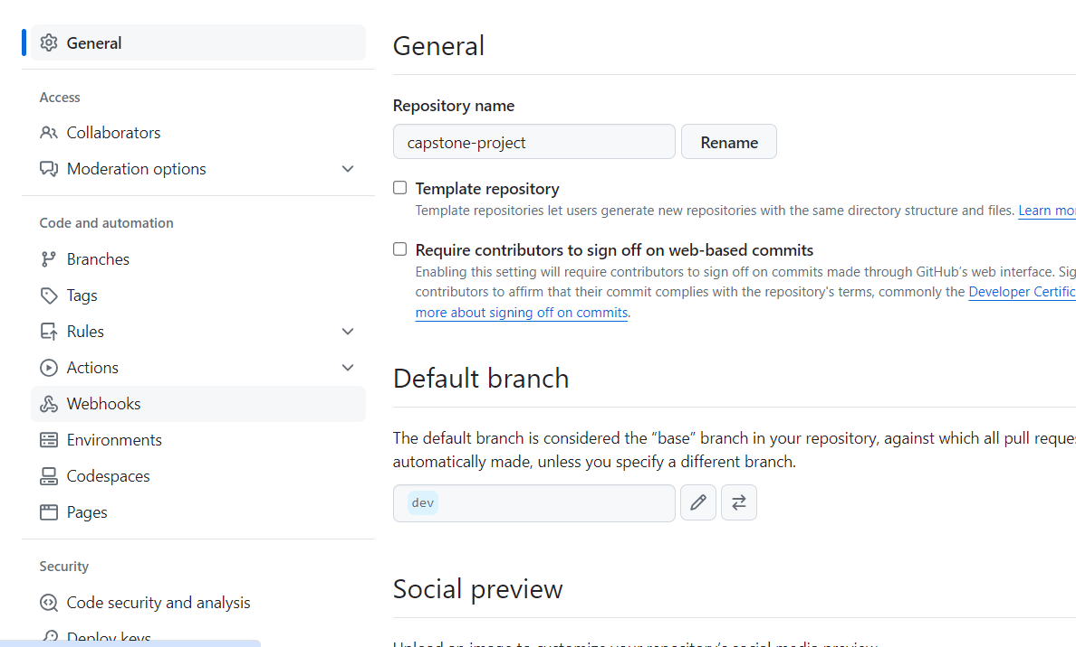

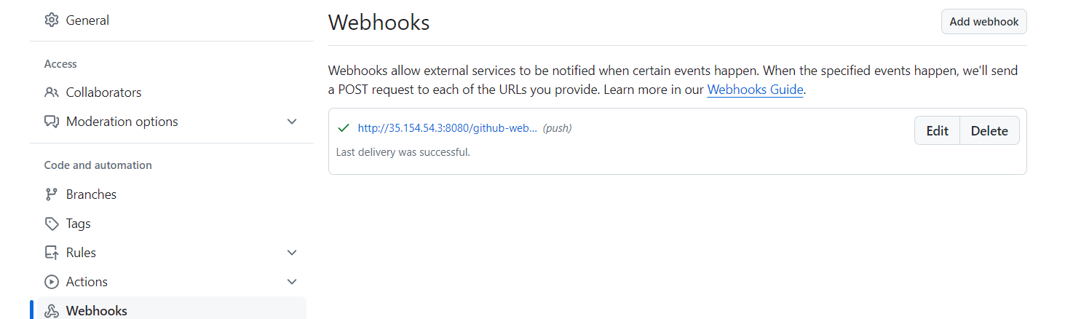

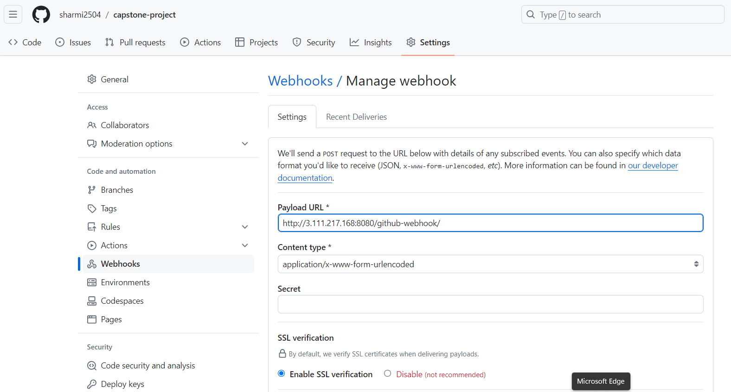

**Create master branch in github:**

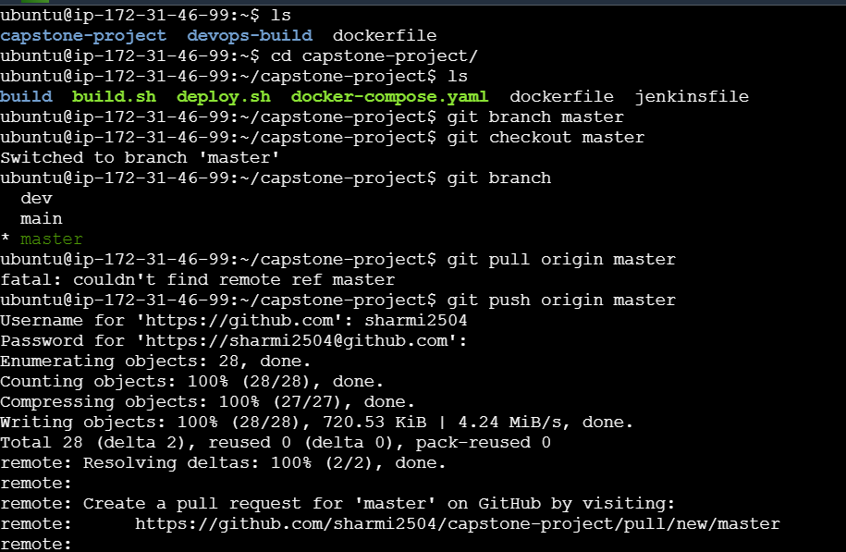

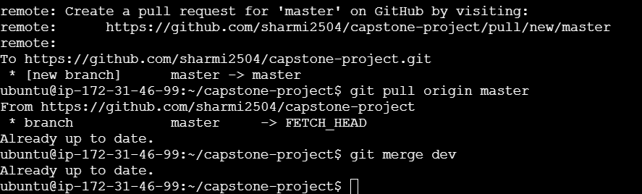

**Pipeline:**

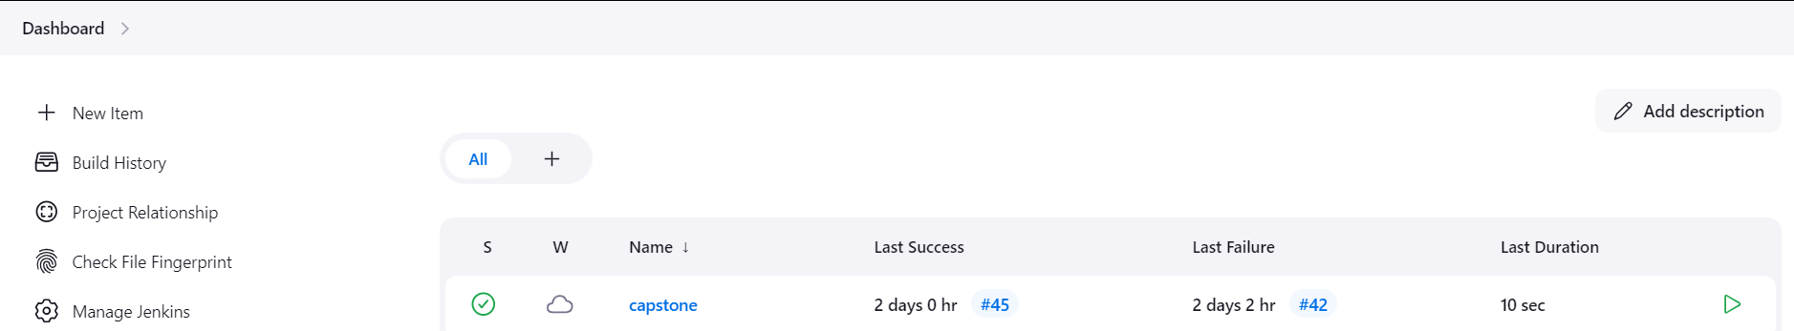

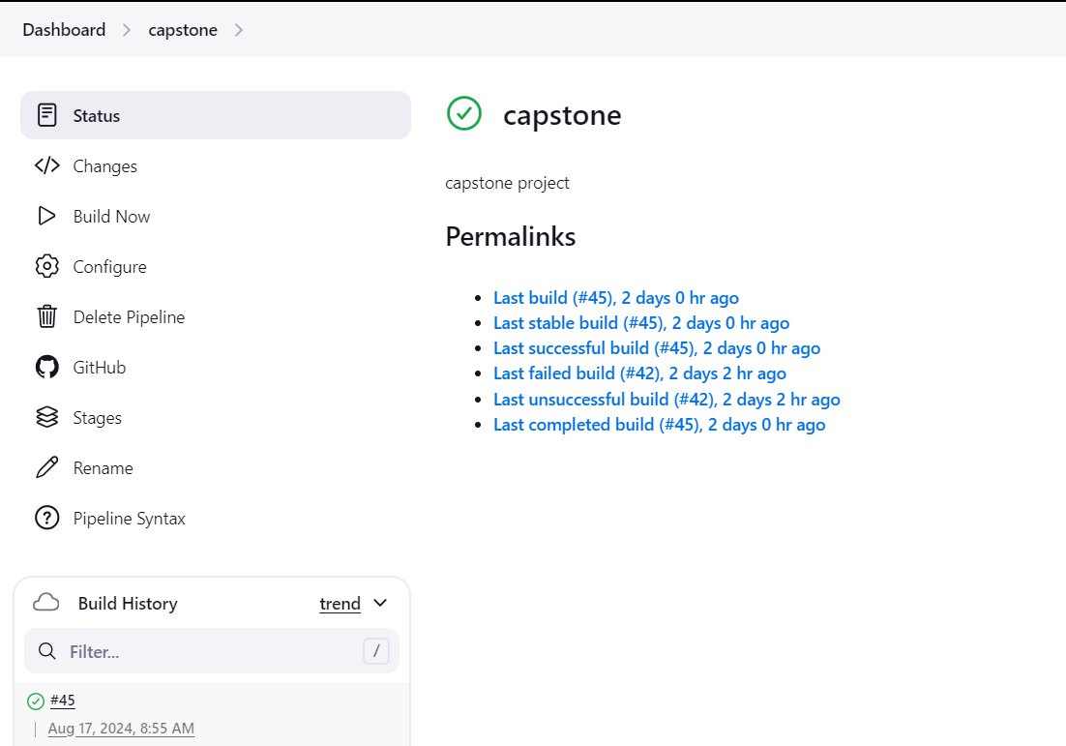

**Create 2 repo in docker:**

1. **Dev repo -public**
2. **Prod- private**

**Dev repo-public:**

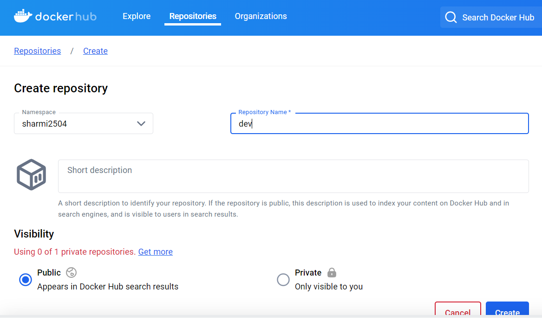

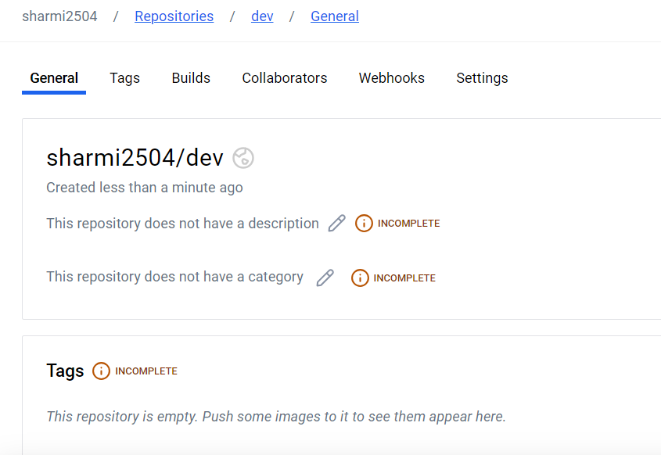

**Prod repo – private:**

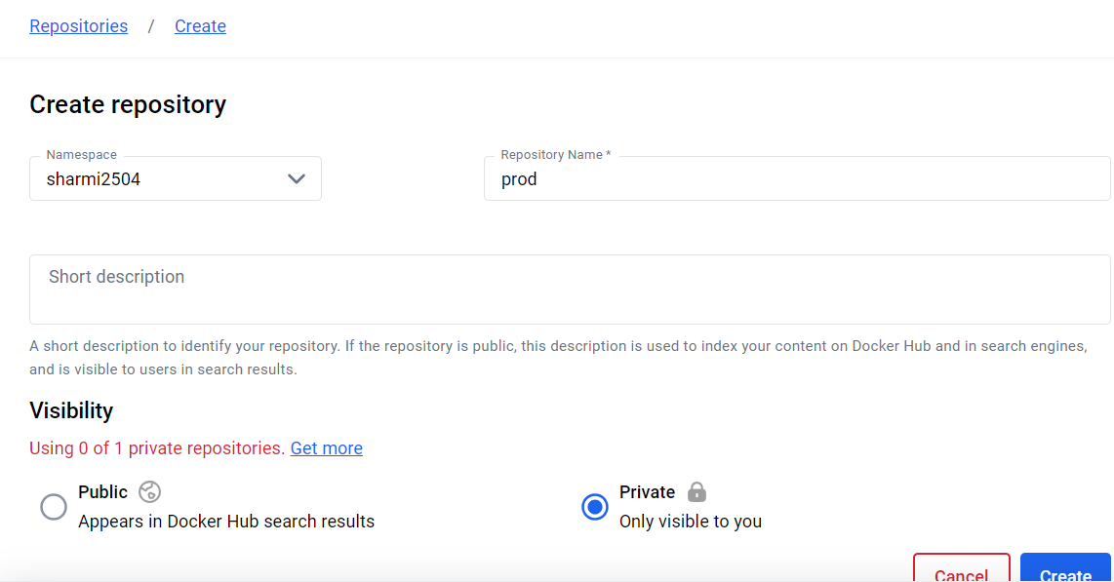

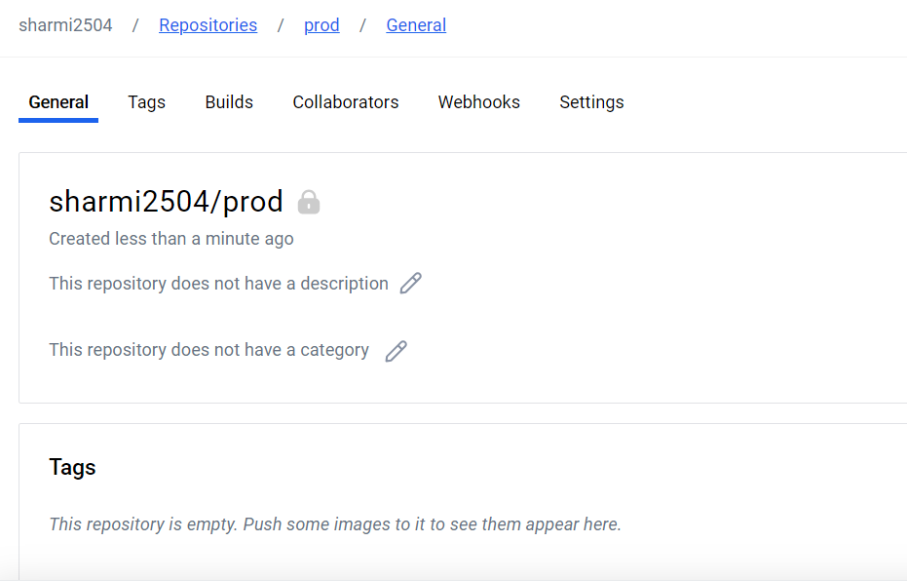

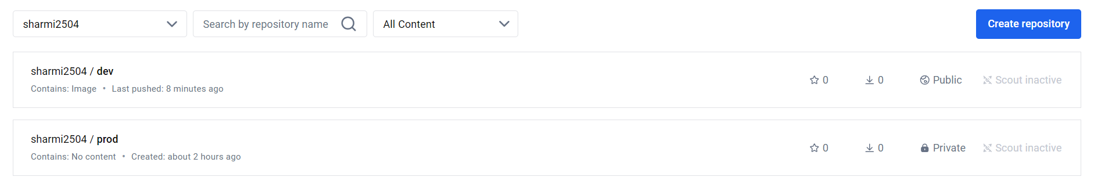

**Multibranch pipeline:**



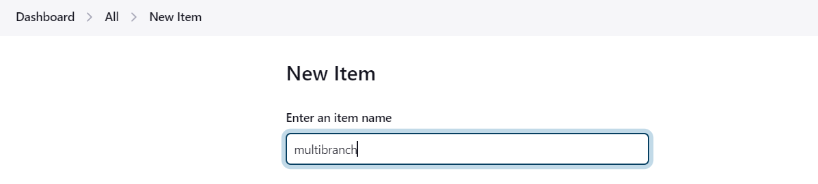

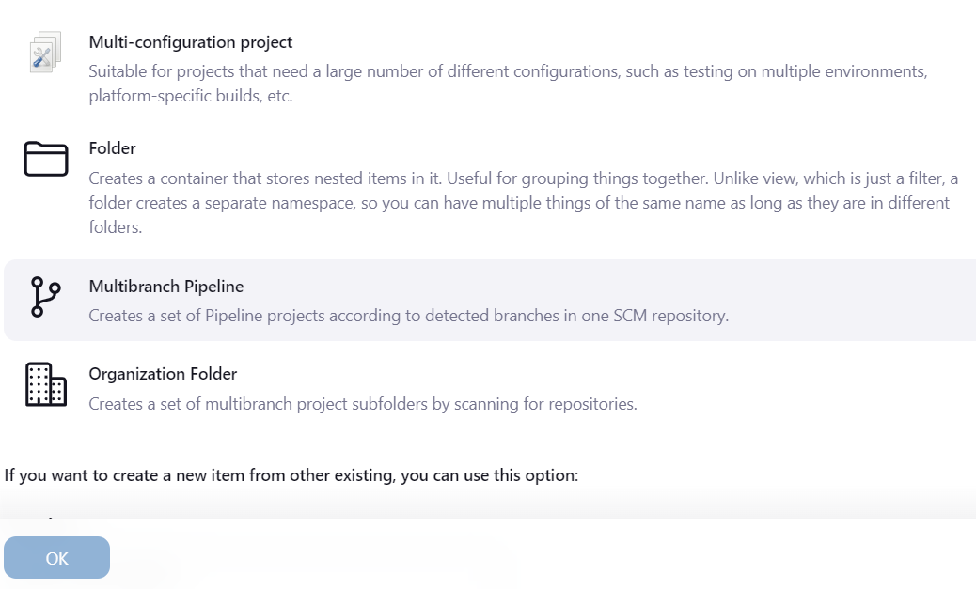

**Configuration:**

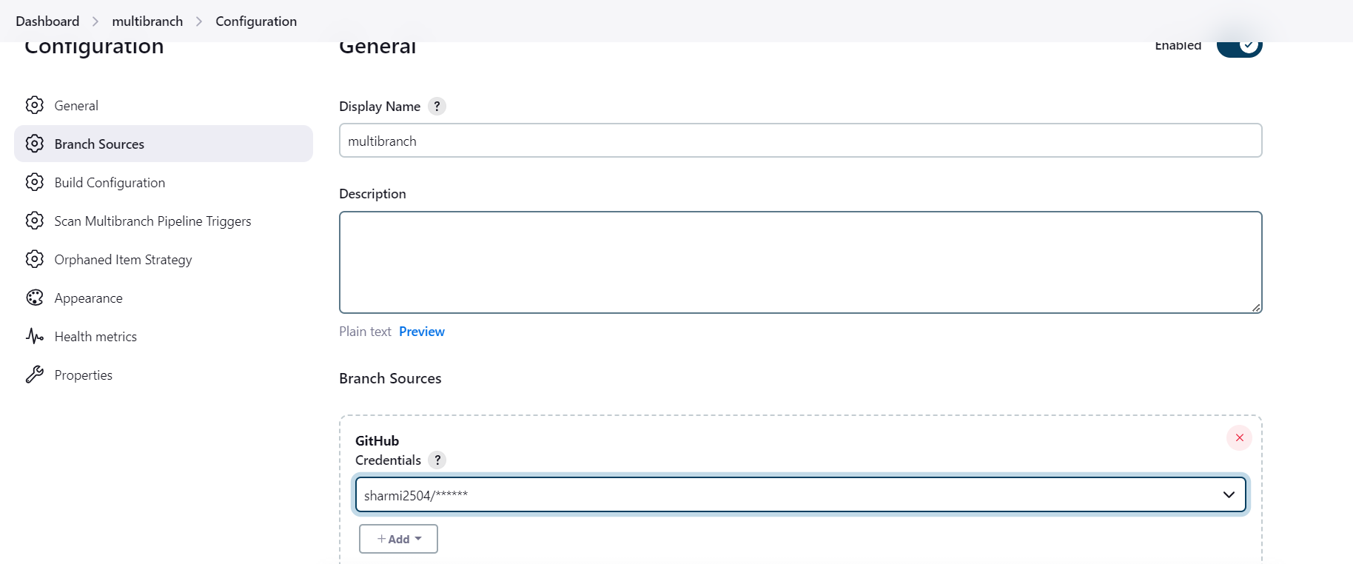

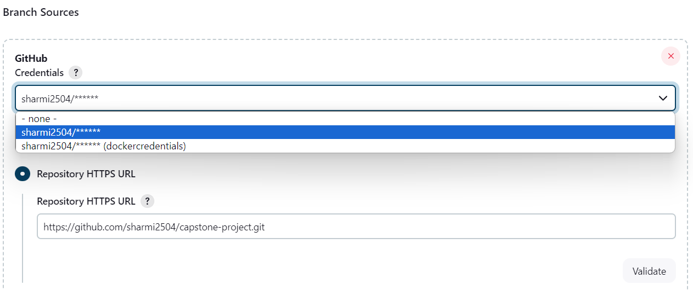

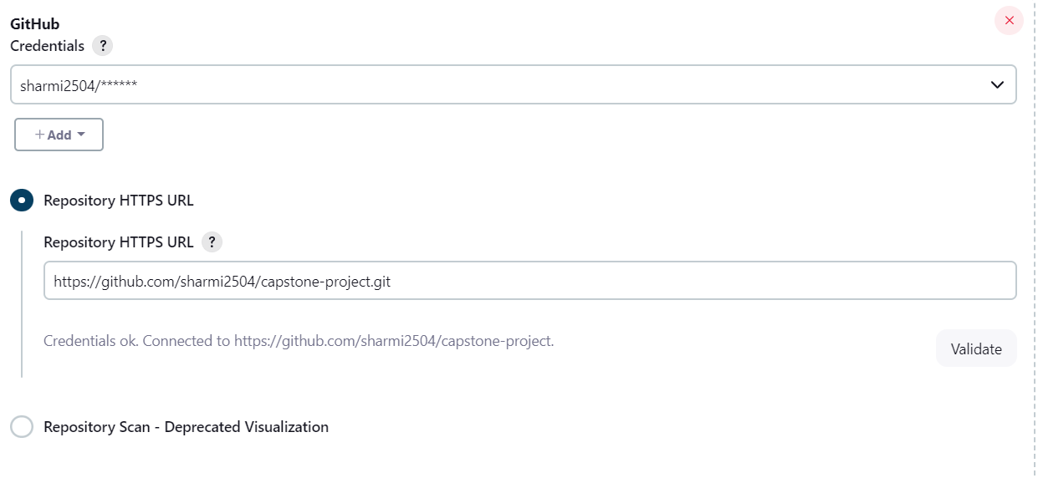

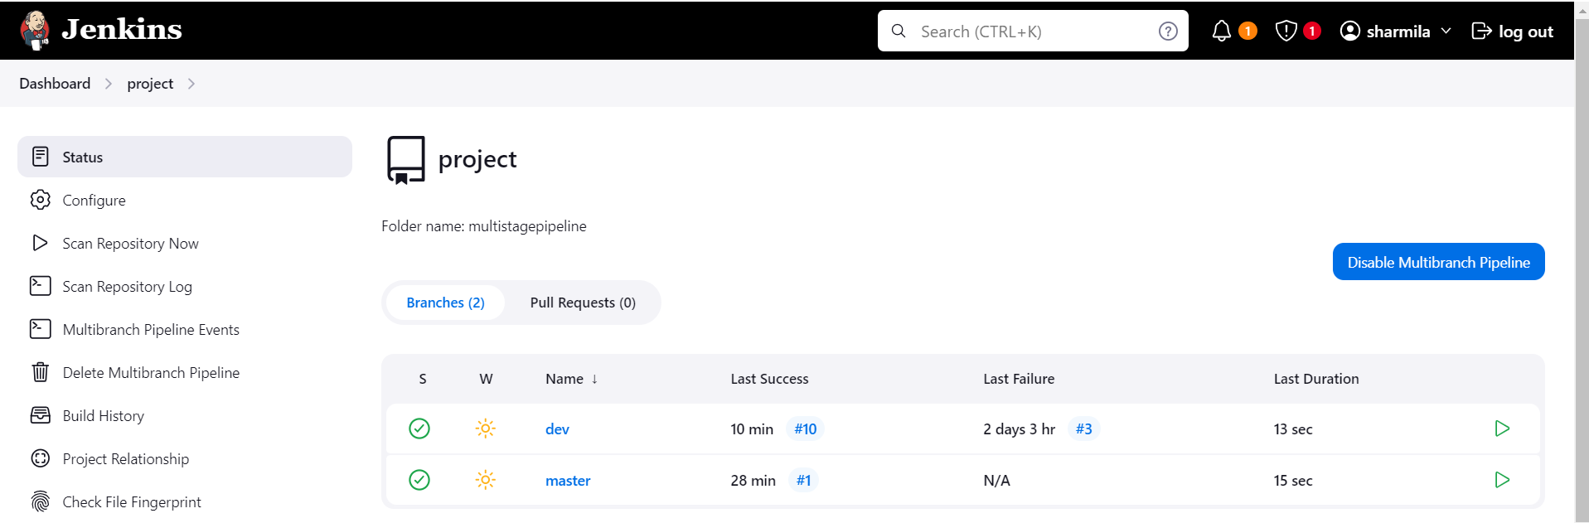

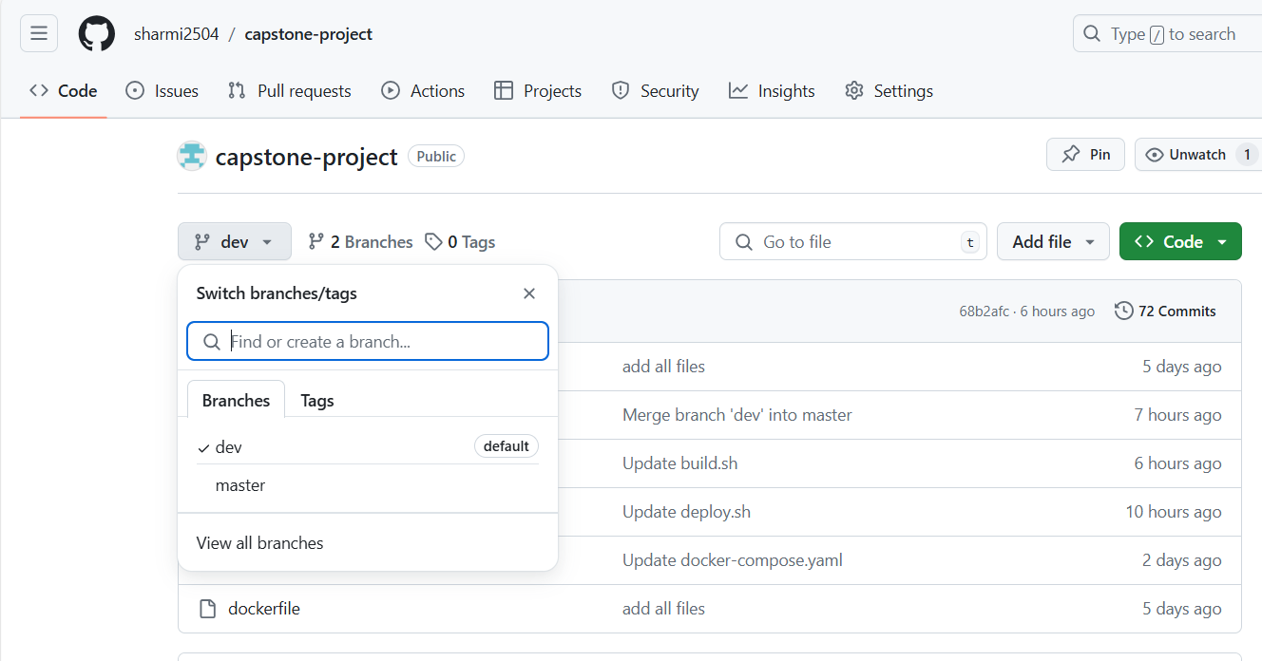

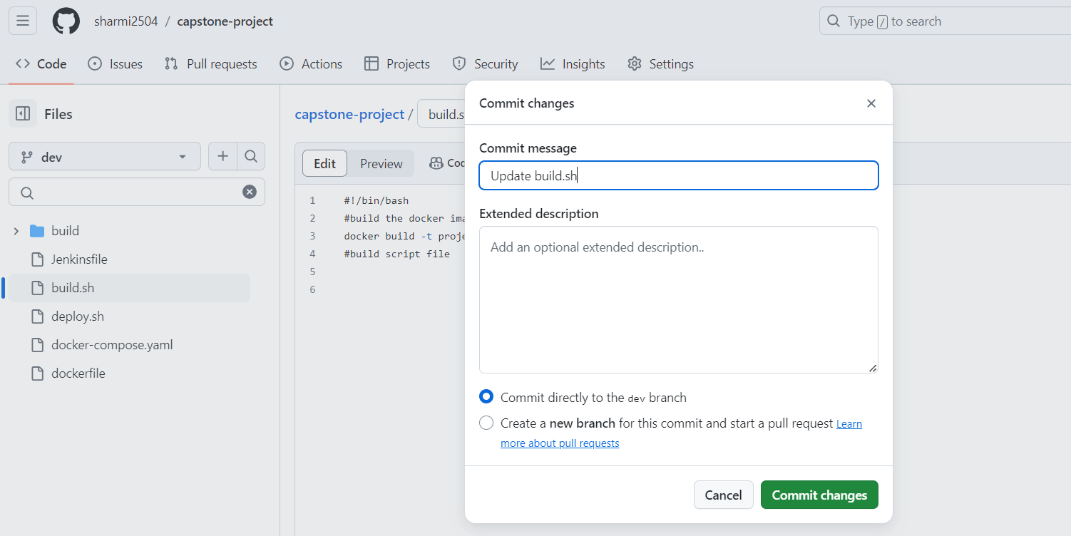

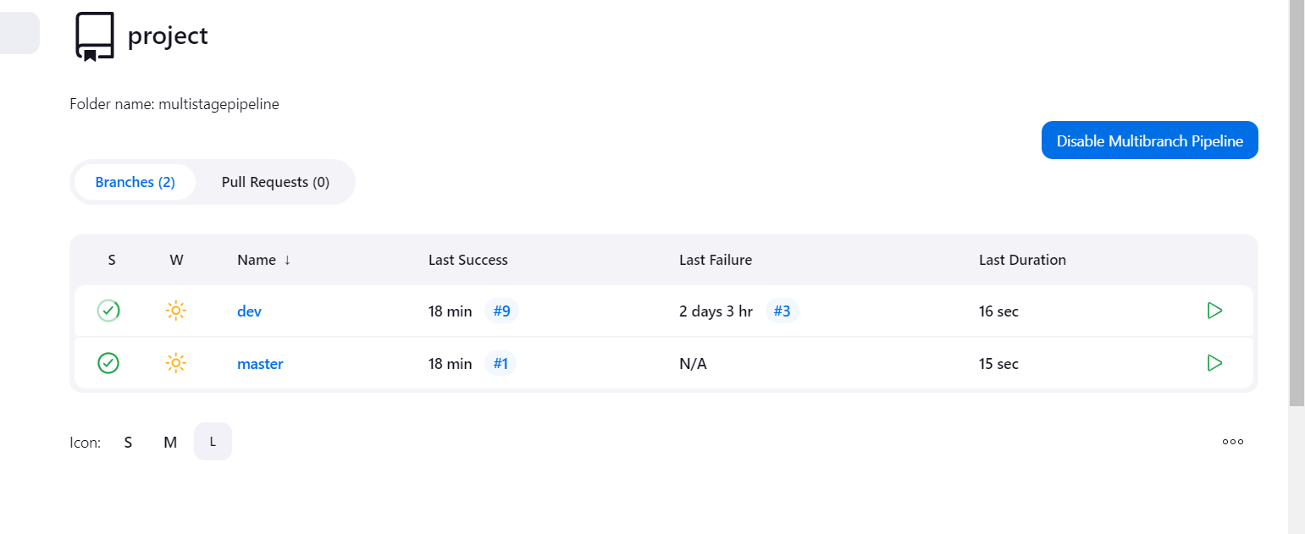

**Image pushed to prod repo:**

**Multipipeline – changes in dev automatically image pushed to dev repo**

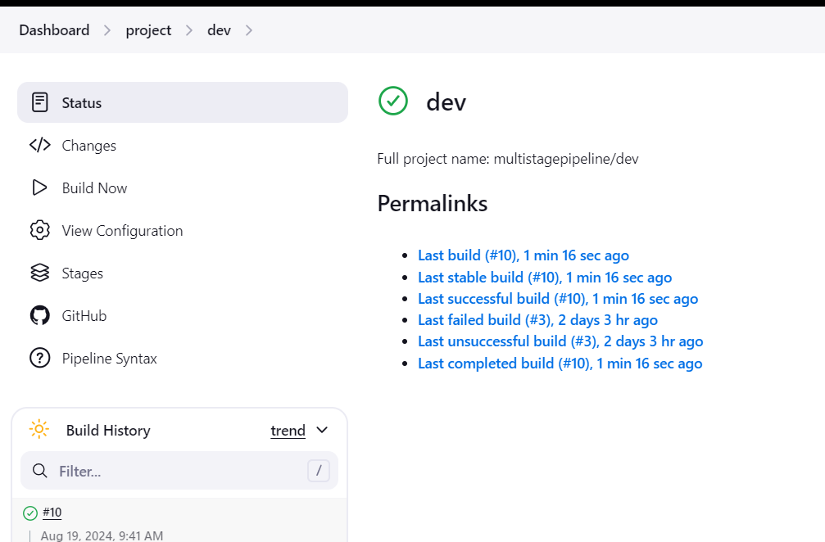

**Console output:**

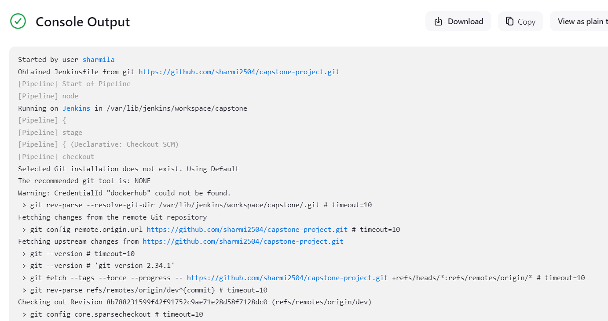

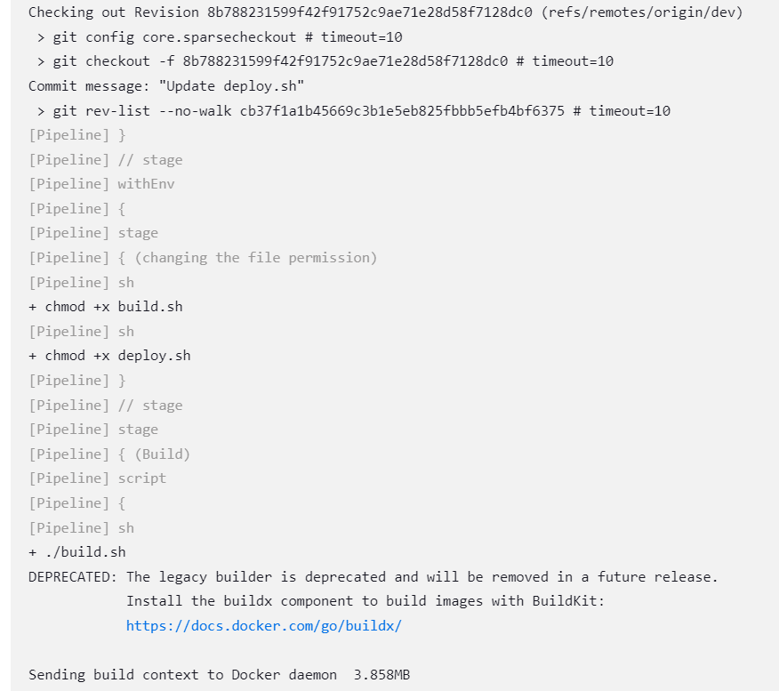

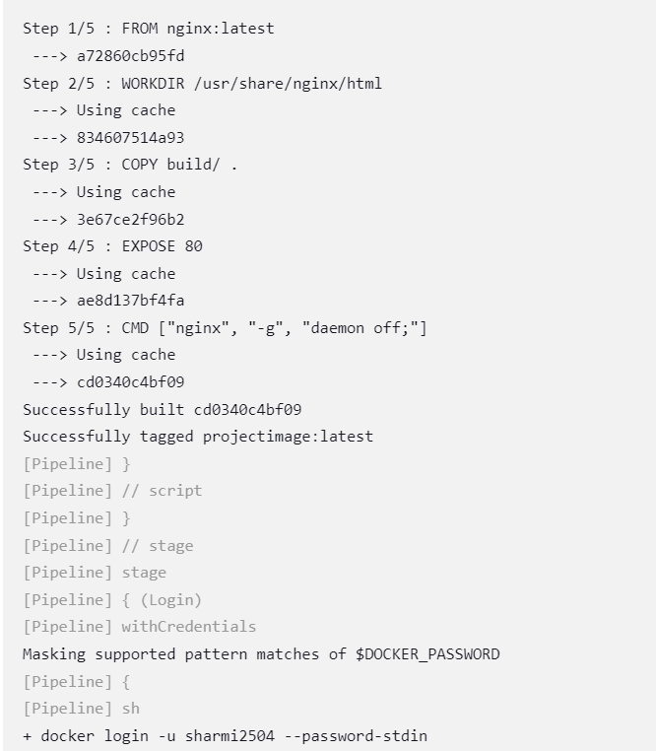

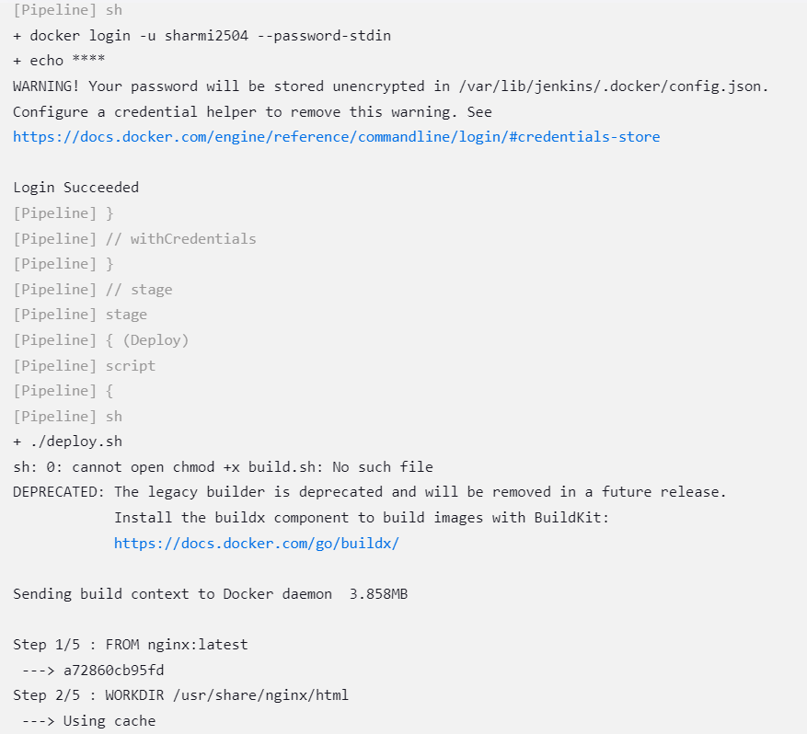

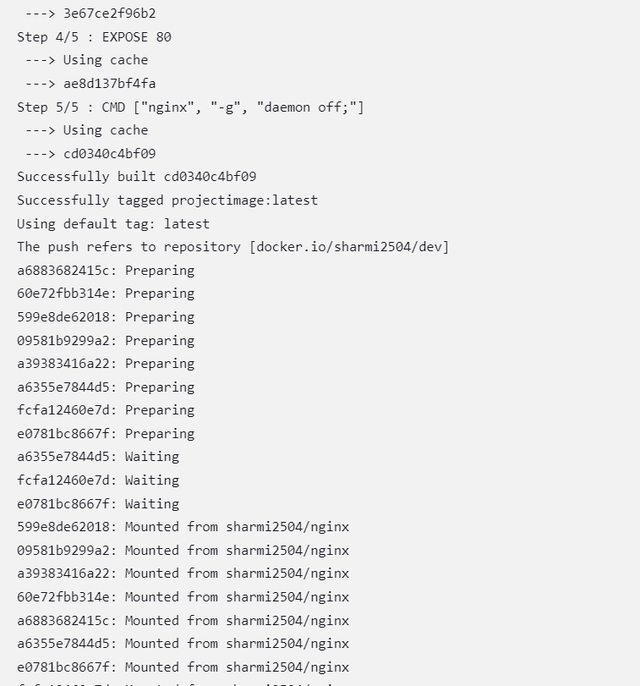

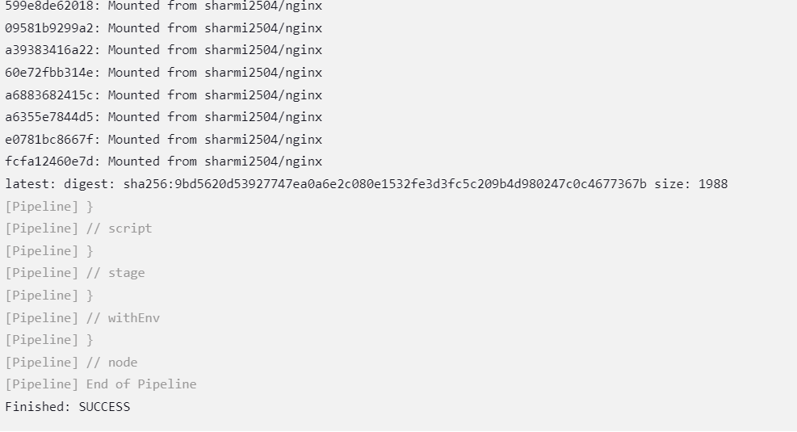

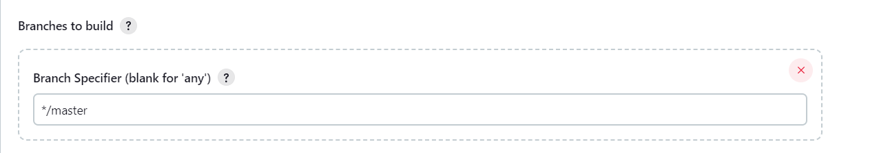

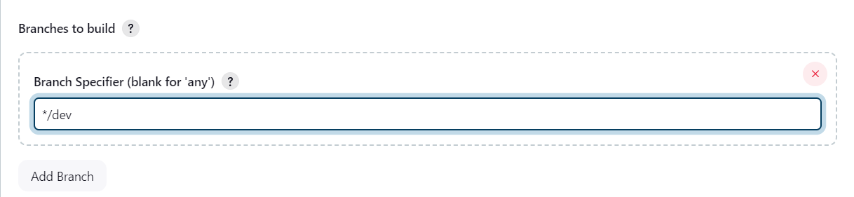

**Image pushed to dev repo:**

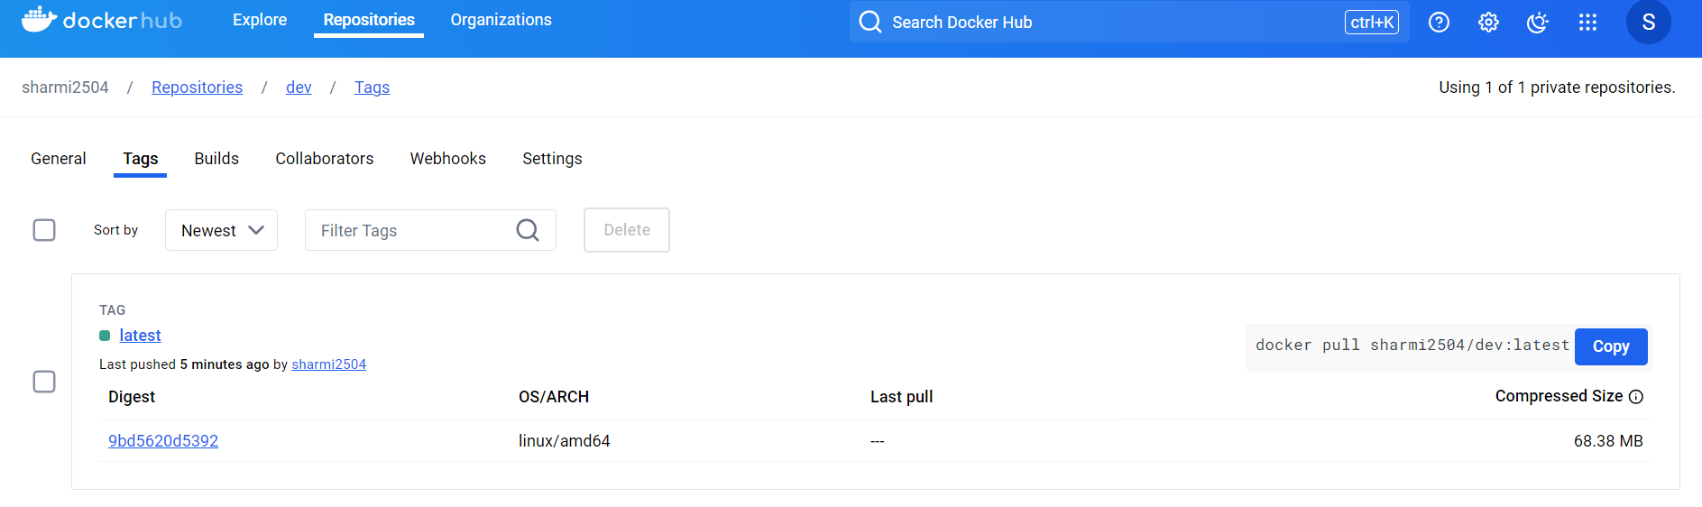

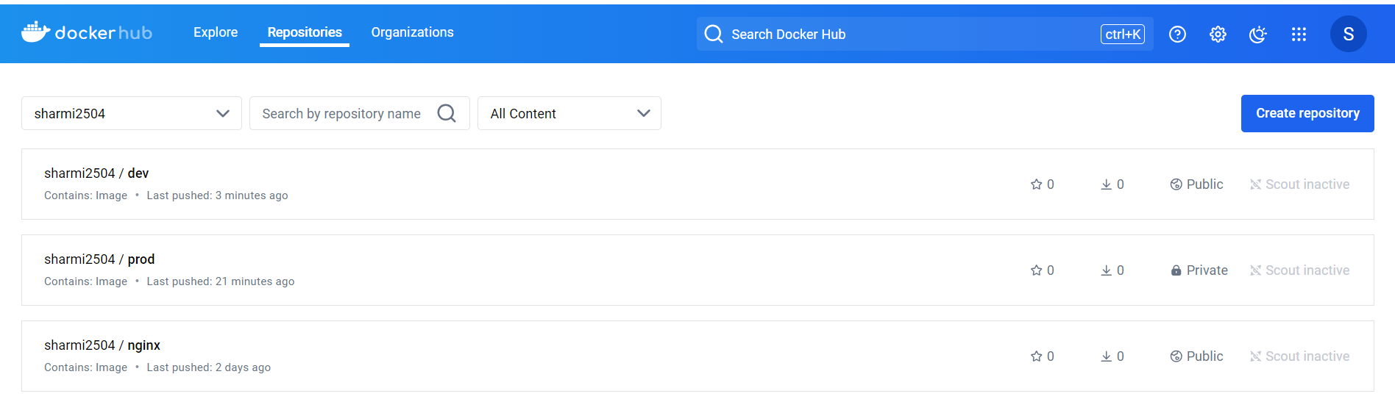

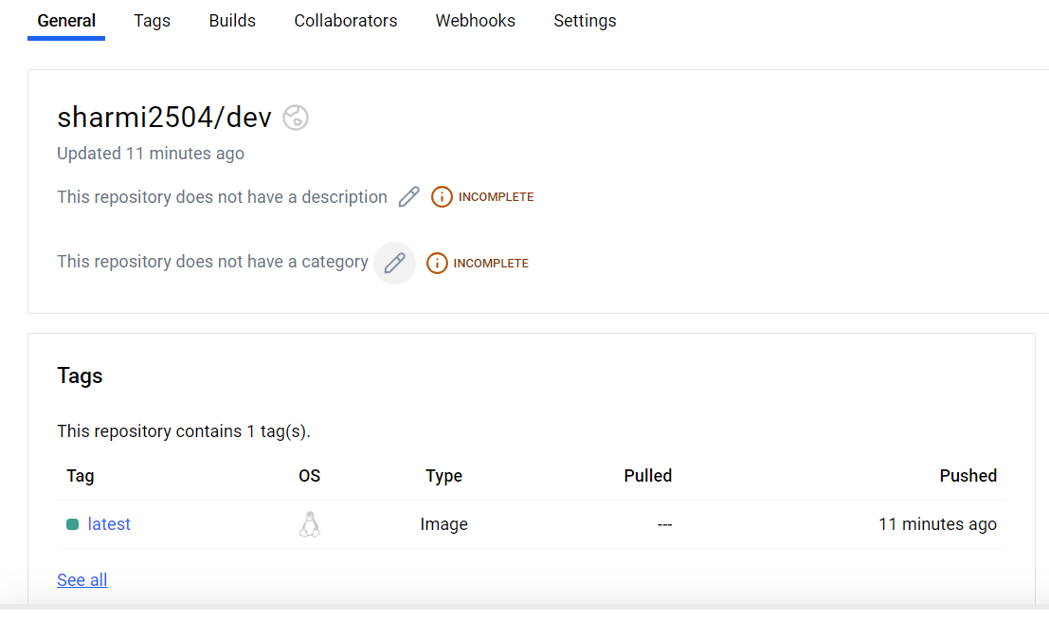

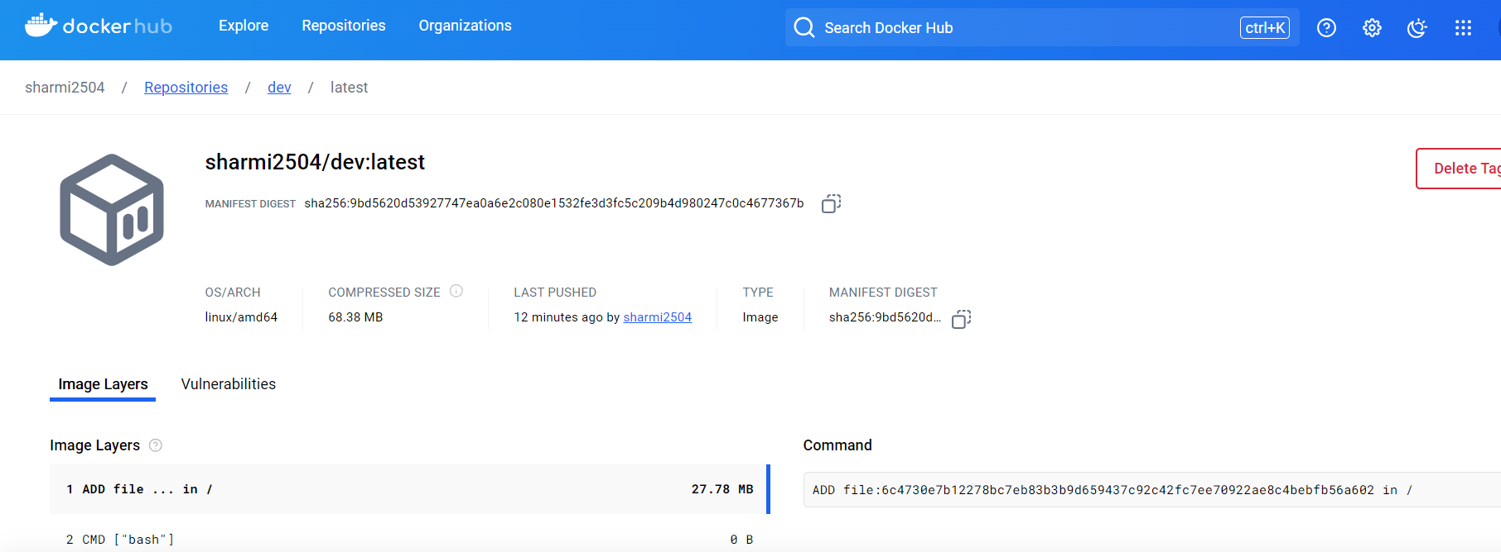

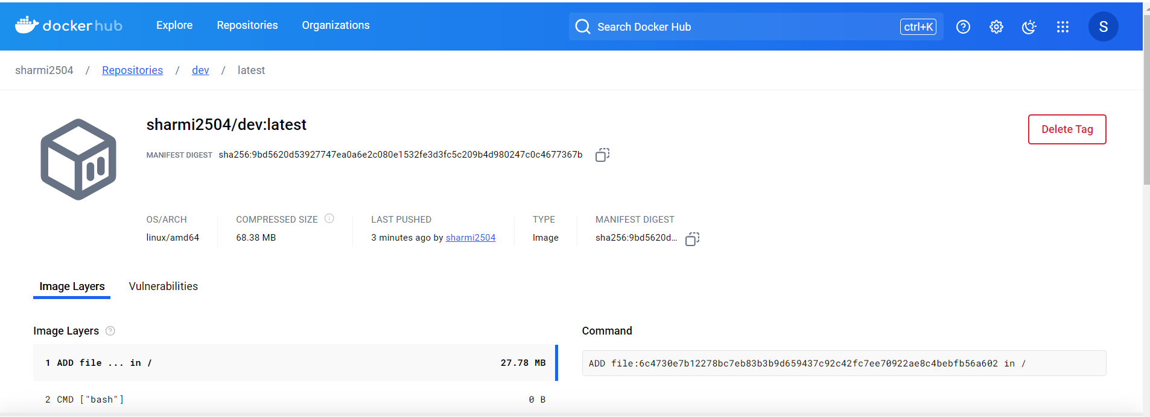

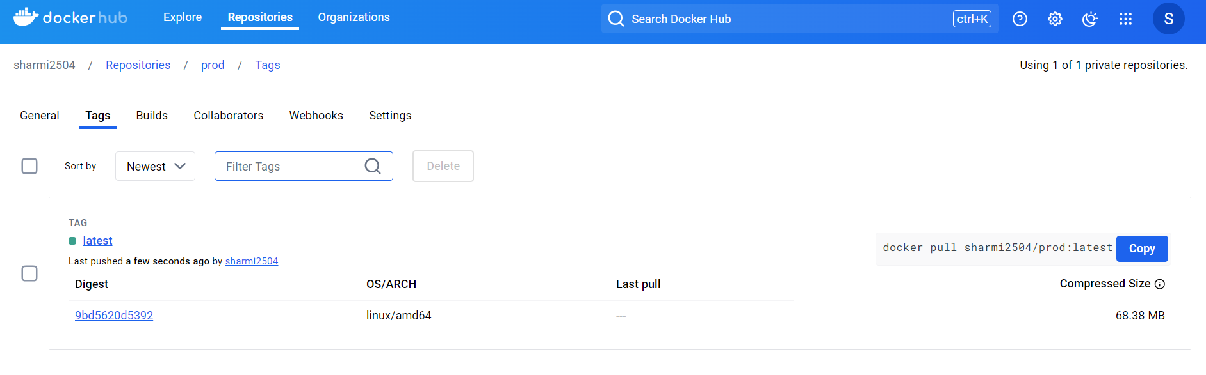

**When changes in prod branch ,Image pushed to prod repo:**

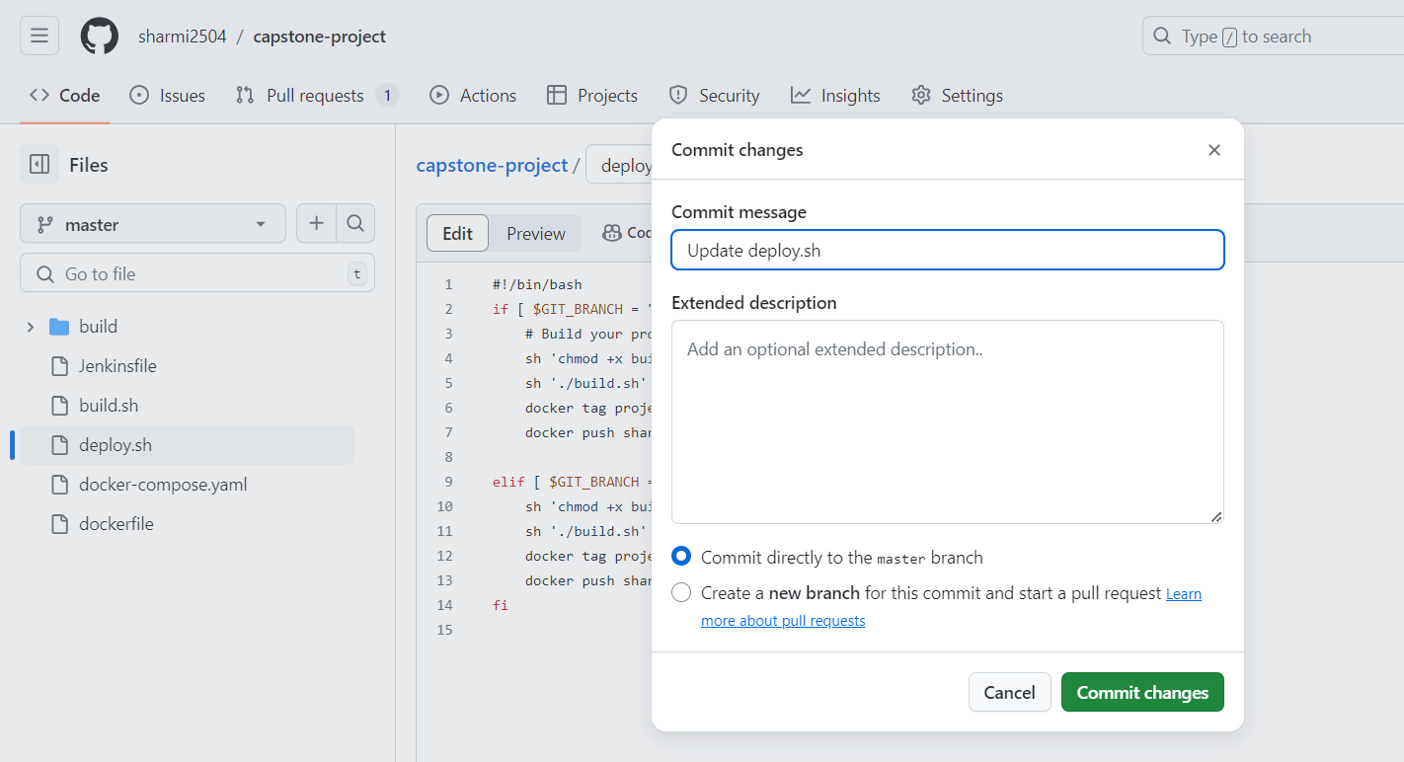

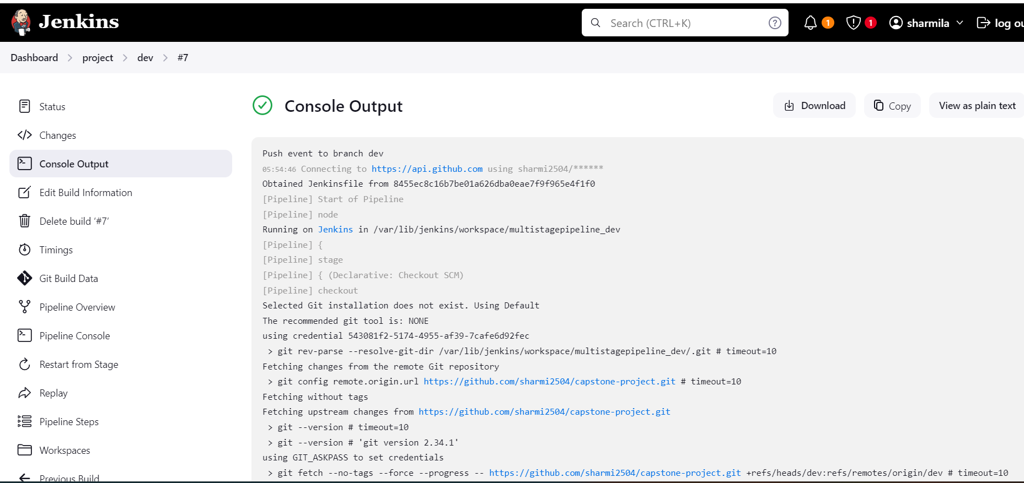

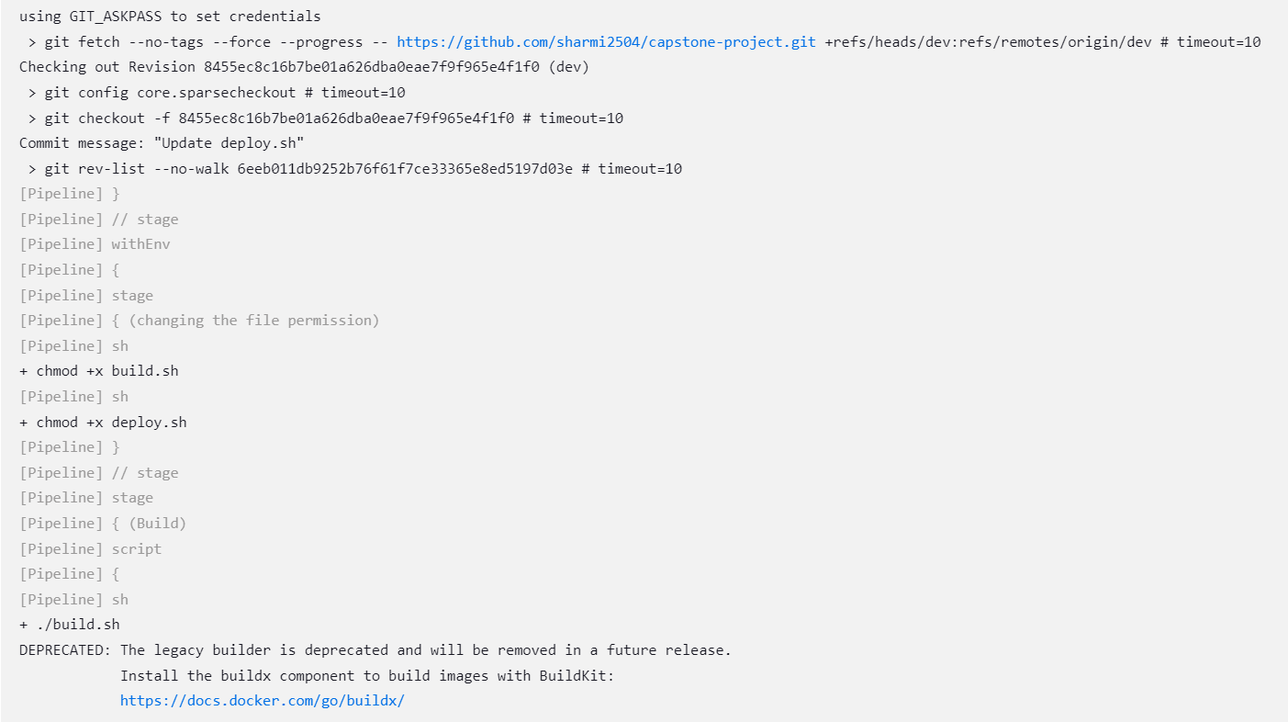

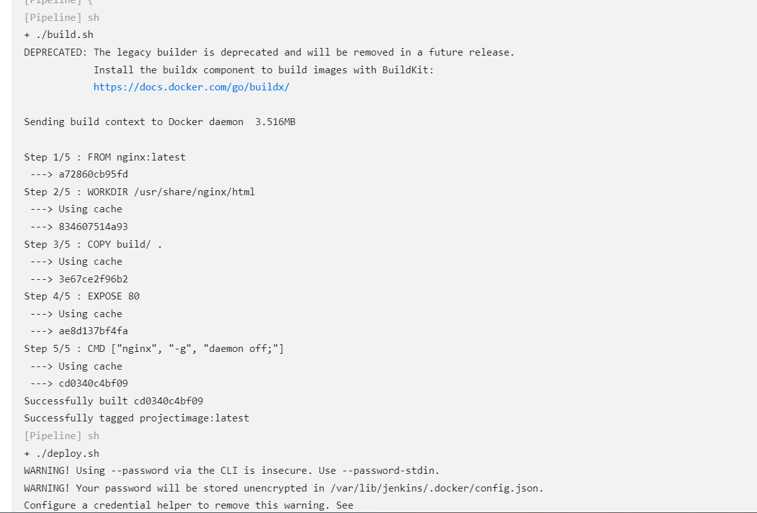

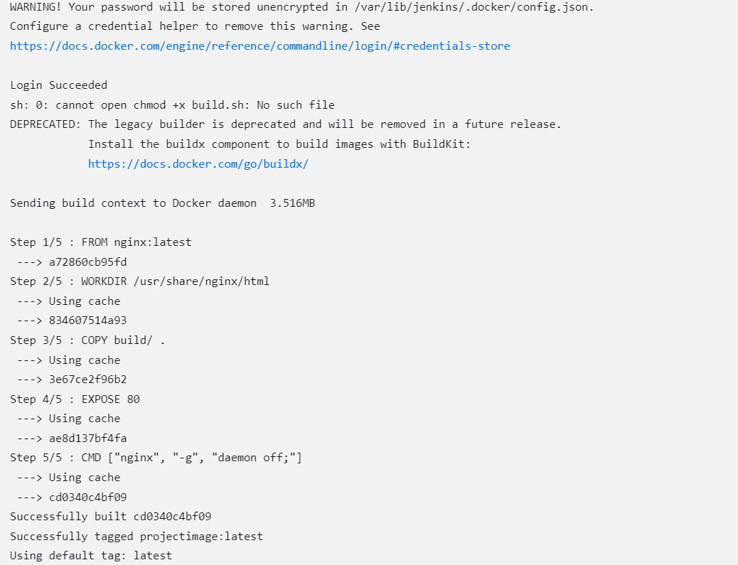

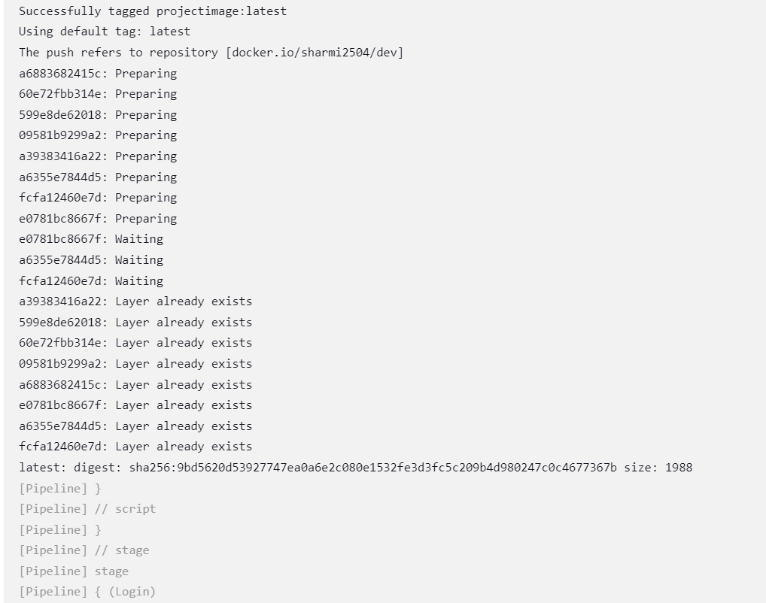

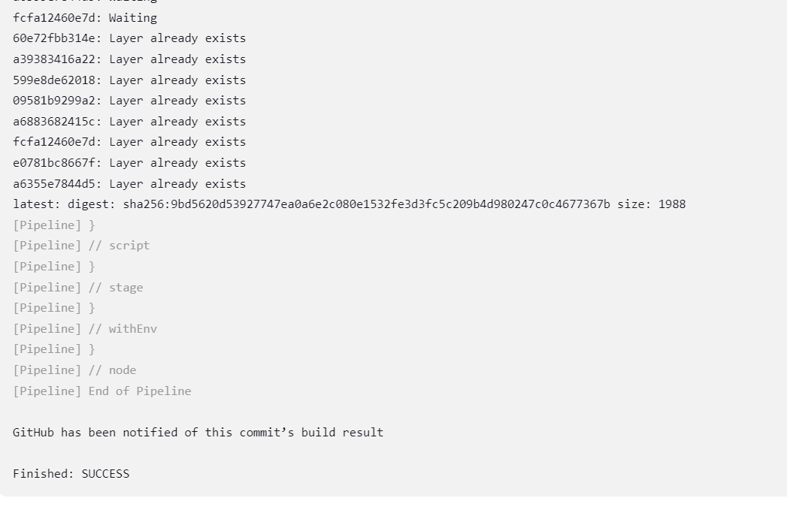

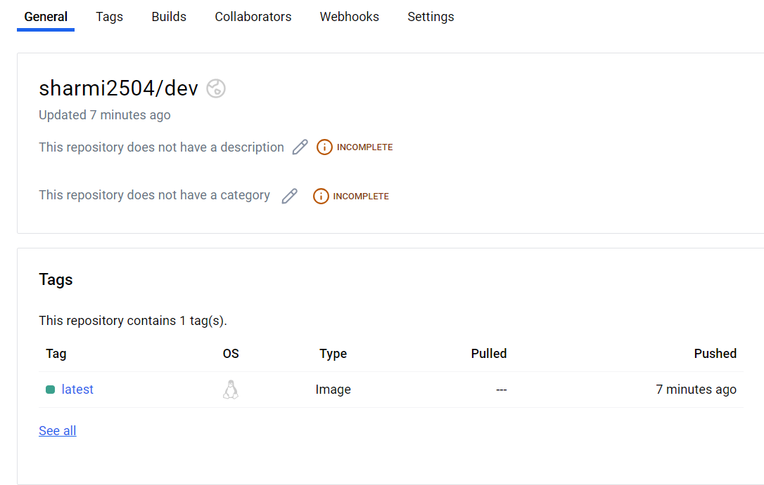

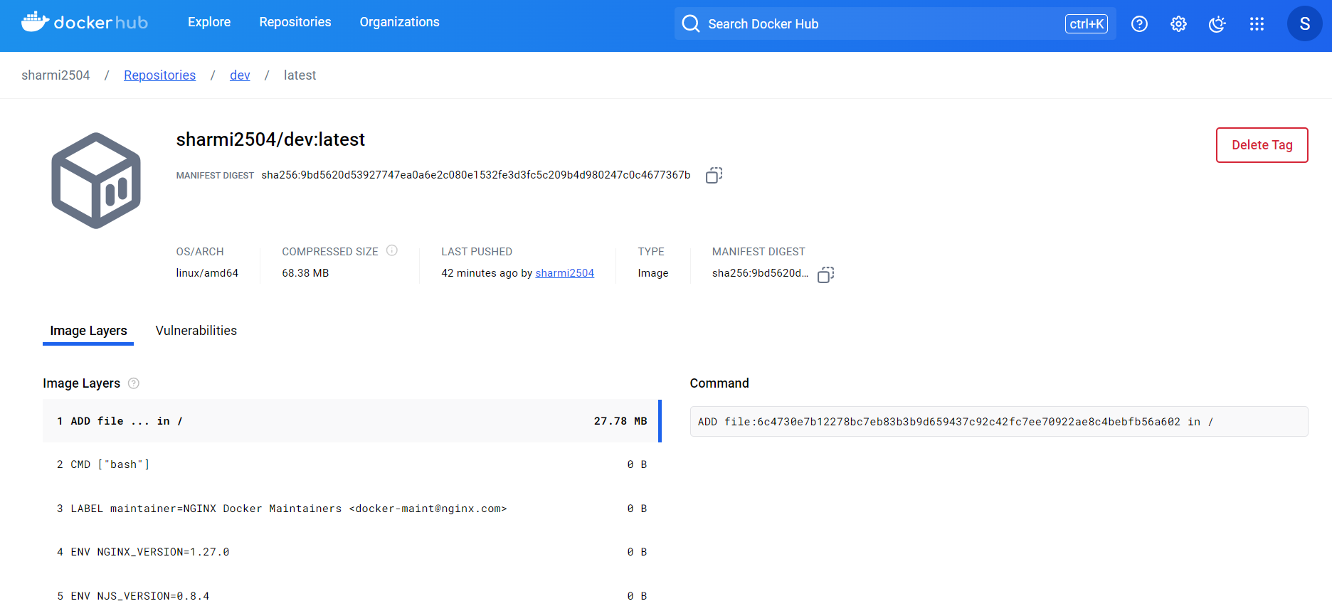

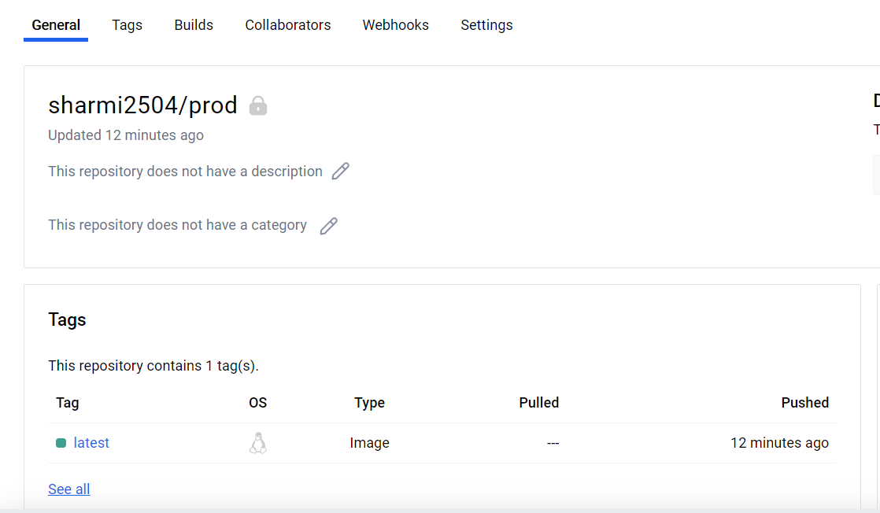

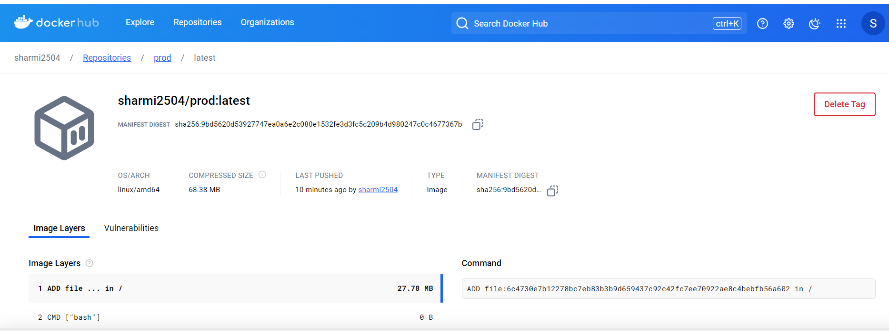

**Monitoring:**

**Prometheus:**

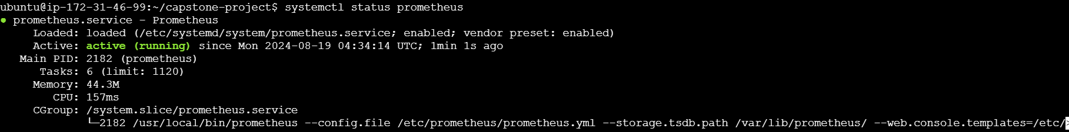

**Node exporter:**

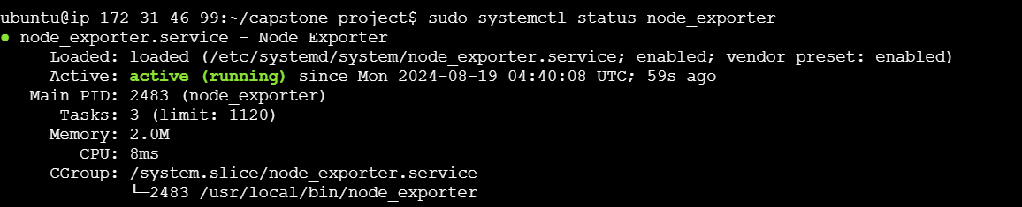

**Grafana:**



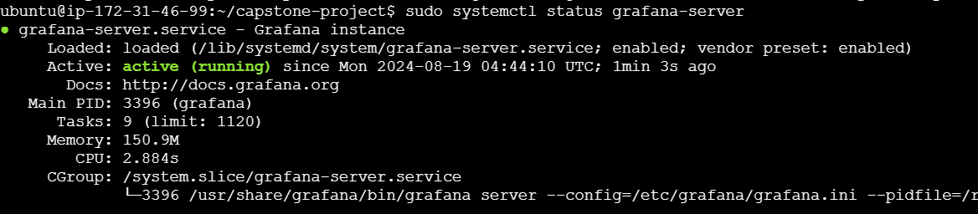

**Open all ports:**

